|  |  |  |  |  |
| --- | --- | --- | --- | --- |
| **Level 5th Unit 5**  **Scope and Sequence** | | | | |
| |  | | --- | | **Dimensions** | | **1.** **Ways of thinking (  )** | | **2. Ways of living in the world  ( X )** | | **3. Ways of relating with others  ( X )** | | **4. Tools for integrating with the world  ( )** | | | | | |
| **Scenario: Tell me a Story** | | | | |
| **Enduring Understanding** | A good story has characters, a setting, a plot, and a theme. There are different story genres such as fairy tales, fiction, nonfiction, poetry, legends, comics and biographies. | | | |
| **Essential  Question** | What makes a good story? | | | |
| **Assessment and Goals** | | | | |
| **Week 1** | **Week 2** | **Week 3** | **Week 4** | **Week 5** |
| **Theme**   1. Once Upon a Time | **Theme**   1. What a Wonderful Story! | **Theme**  3. Acting It Out | **Theme**  4. Let´s Write a Story |  |
| **Assessment:**  **L1.** Recognizes the main points in short, simple stories and reports when there is some previous understanding of the topic and if they are read slowly, clearly and possibly repeated.  **R1.** Recognizes readings, analyzes and enjoys texts.  **SI.1.** Asks others about what they like and dislike.  **R.P.A. 1** Shows knowledge of phonemic awareness by pronouncing sounds /s / z/ in initial position.  **Goals:**  **L.1.** understand the main points in short, simple stories and reports when there is some previous understanding of the topic and if they are read slowly, clearly and possibly repeated.  **R.1.** comprehend readings, analyze and enjoy texts.  **SI.1.** ask others about what their likes and dislikes.  **R.P.A. 1** demonstrate knowledge of phonemic awareness by pronouncing sounds /s / z/ in initial position. | **Assessment:**  **L2.** Recognizes phrases and high frequency vocabulary related to areas of personal interest.  **R2.** Recognizes most of what occurs in a well-structured short story and the story’s main characters.  **SI.2** Exchanges information about everyday matters using simple vocabulary.  **R.P.A.**1Shows knowledge of phonemic awareness by pronouncing sounds /ŋk / ŋ/ in final position.  **Goals:**  **L.2.** understand phrases and high frequency vocabulary related to areas of personal interest.  **R.2.** understand most of what occurs in a well-structured short story and can identify the story’s main characters.  **SI.2** exchange information about everyday matters using simple vocabulary.  **R.P.A.**1 demonstrate knowledge of phonemic awareness by pronouncing sounds /ŋk / ŋ/ in final position. | **Assessment:**  **SP.1.** Describes basic aspects of a story, fairy tale or fable.  **W1.** Writes, with the help of illustrations, a little short story or fairy tale.  **R.P.A.1** Shows knowledge of phonemic awareness by pronouncing sounds the diagraphs (th, sh) in initial position.  **Goals:**  **SP.1.** describe basic aspects of their day-by-day life, such as favorite foods and daily activities.  **W.1.** write a short text with the help of illustrations, a little short story or fairy tale.  **R.P.A.1** demonstrate knowledge of phonemic awareness by pronouncing sounds the diagraphs (th, sh) in initial position. | **Assessment:**  **SI.2** Exchanges information about everyday matters using simple vocabulary.  **W2.** Applies conventions of standard English when writing a short text.  **R.P.A.** 1 Shows knowledge of phonemic awareness by pronouncing sounds the diagraphs (ph) in initial position.  **Goals:**  **SI.2** exchange information about everyday matters using simple vocabulary.  **W.2.** apply conventions of standard English.  **R.P.A.** 1 demonstrate knowledge of phonemic awareness by pronouncing sounds the diagraphs (ph) in initial position. | **Assessment**  **Instruments for Process/Product**  **Week 6**  **Suggested Integrated Mini project** |
| **Function**   * Identifying the components of a story * Describing likes and dislikes | **Function**   * Describing setting and characters | **Function**   * Describing the main events in a story | **Function**   * Describing past events |  |
| **Discourse Markers**  Sequence adverbs-past tense  First, next, then, finally | **Discourse Markers**  Sequence adverbs-past tense  First, next, then, finally | **Discourse Markers**  Sequence adverbs-past tense  First, next, then, finally | **Discourse Markers**  Sequence adverbs-past tense  First, next, then, finally |

|  |  |  |  |  |
| --- | --- | --- | --- | --- |
| **Grammar & Sentence Frames**  Simple Preset Tense   * The story takes place in ___. * The characters are_________ * The story begins in/with _____. | **Grammar &Sentence Frames**    Present progressive   * The main character is talking about. * The man is running when he sees a tall woman next to him. | **Grammar & Sentence Frames**  Present perfect   * The three men have lived in the house for many years. * The child has not done the bed yet. | **Grammar & Sentence Frames**  Simple Past   * One upon a time, there was/were ____. * The story was about _____.   Interrogative past sentences beginning with “What.”; "Where"; "Who”   * Where did the story take place? * What was the story about?   Who felt sad in the story? |  |
| **Phonemic Awareness**  Practicing minimal pair sounds**: s / z**   * **sip / zip** * **sue / zoo** * **place / plays** * **rice / rise** * **ice / eyes** | **Phonemic Awareness**  Practicing minimal pair sounds**: ŋk / ŋ**   * **think / thing** * **sank / sang** * **bank / bang** * **rink / ring** * **sunk / sung** | **Phonemic Awareness**  Practicing digraphs   * **(th, sh,ph)** * **phone, photo** * **think, teeth,** * **she, shield** | **Phonemic Awareness**  Practicing digraphs   * **(th,sh, ph)** * **think, teeth,** * **she, shield** * **phone, photo** |

|  |  |  |  |  |
| --- | --- | --- | --- | --- |
| **Vocabulary**  1.Once upon a time  Literature types   * Fables, short stories, fairy tales, comics, poetry, legends   Expressions and phrases   * What´s your favorite book/novel/ fairy- tale? My favorite story is______. * I like short stories, but I don´t like novels. * My favorite fairy-tale is _____ because_____ * My favorite story character is ____because_.   Adjectives   * Interesting * Hilarious * Entertaining | **Vocabulary**  2. What a wonderful story!  Expressions and phrases   * What is the story about? * Who are the main characters? * What did you like the most?   Descriptive words   * Crooked, Deep * Huge, Skinny * Bitter, Delicious * Ancient, Mean * Good   Adverbs   * Far away | **Vocabulary**  3.Acting it out  Expressions and phrases   * What´s my role? * What should I do? * Who goes first, second? * When is my turn?   Actions   * vary tone and volume of voice * Express your emotions ( anger, delight, surprise, worry, fear) * Dress costumes * Use body language, miming and gesturing * Use pauses * Elicit and ask questions * Let´s put some special effects with sounds | **Vocabulary**  4.Let´s write a story  Parts of a story   * Characters, setting, plot, conflict   Descriptive Adjectives   * attractive, adorable,   Story characters   * dragon, witch, princess   Transition words, connectors, sequence words  Then, furthermore, after, finally |  |
| **Psycho-social**   * Developing appreciation for literature   **Sociocultural**   * Recognizing the importance of literature in people´s lives.   **Idioms/phrases**   * God helps those who help themselves= Don´t just wait for things to happen to you. Work hard to achieve your goals. | **Psycho-social**   * Developing a favorable attitude towards books as a way to enrich life   **Sociocultural**   * Recognizing the importance of literature in people´s lives.   **Idioms/phrases**   * Don´t count your chickens before they are hatched.= You should not count on something until it happens. | **Psycho-social**   * Stimulating and expanding creativity and imagination   **Sociocultural**   * Gaining multiple cultural perspectives through the reading of literature pieces   **Idioms/phrases**  She found her prince charming. = She found her ideal mate. | **Psycho-social**   * Stimulating and expanding creativity and imagination   **Sociocultural**   * Gaining multiple cultural perspectives through the reading of literature pieces   **Idioms/phrases**  She cried crocodile tears. = She cried fake tears. |  |

|  |  |  |  |  |  |  |  |  |  |
| --- | --- | --- | --- | --- | --- | --- | --- | --- | --- |
| **Term: III** | | **Level: Fifth Grade** | | | **Unit: 5** | | | **Week:1** | |
| **Domain: Socio-interpersonal** | | | | **Scenario: Tell me a Story** | | **Theme:**  Once Upon a Time | | | |
| **Enduring Understanding**: A good story has characters, a setting, a plot, and a theme. There are different story genres such as fairy tales, fiction, nonfiction, poetry, legends, comics and biographies. | | | | | | | | | |
| **Essential Question:** What makes a good story? | | | | | | | | | |
| |  | | --- | | **Dimensions** | | **1.** **Ways of thinking ( X )** | | **2. Ways of living in the world  ( X )** | | **3. Ways of relating with others  ( X )** | | **4. Tools for integrating with the world  ( )** | | | | | | | | | | |
| **Learn to Know** | | | | **Learn to Do** | | **Learn to Be and Live in Community** | | | |
| **Grammar & Sentence Frames**  Simple Preset Tense   * The story takes place in ___. * The characters are_________ * The story begins in/with _____.   **Phonemic Awareness**  Practicing minimal pair sounds**: s / z**   * **sip / zip** * **sue / zoo** * **place / plays** * **rice / rise** * **ice / eyes**   **Vocabulary**  1.Once upon a time  Literature types   * Fables, short stories, fairy tales, comics, poetry, legends   Expressions and phrases   * What´s your favorite book/novel/ fairy- tale? My favorite story is______. * I like short stories, but I don´t like novels. * My favorite fairy-tale is _____ because_____ * My favorite story character is ____because_.   Adjectives   * Interesting * Hilarious   Entertaining | | | | **Function**   * Identifying the components of a story * Describing likes and dislikes   **Discourse Markers**  Sequence adverbs-past tense  First, next, then, finally | | **Psycho-social**   * Developing appreciation for literature   **Socio-cultural**   * Recognizing the importance of literature in people´s lives.   **idioms/ phrases**  God helps those who help themselves= Don´t just wait for things to happen to you. Work hard to achieve your goals. | | | |
| **Assessment Strategies & Evidences of learning**  (Diagnostic, formative, summative) | **Goals** | | | **Pedagogical Mediation/ Didactic Sequence** | | | | | **Time** |
| Learner… | Learner can | | | ***CONNECTION***  **Pre-teaching**  Routine: Checking attendance, checking in with Ls, T posts the Essential Question, goal, Can Do’s, and class agenda, etc. on the board  ***COLLABORATION***  **Warm up**  Teacher shows one part of the YouTube video: The Proud Horse and The Donkey Story in English / Stories for Teenagers | English Fairy Tales <https://www.youtube.com/watch?v=lMno9beR64g> until minute 5:59, and asks learners to take notes on what they understand about it, the principal ideas. Learners share their list of notes in pairs, and then with the whole group.  **Activation of Prior Knowledge**  As soon as they finish sharing their notes, the teacher will guide the students with some flashcards or the presentation attached with the review of the vocabulary, such as            Then the teacher will ask the students the following questions:  Do you like stories?  Which is your favorite story?  Who are the main characters?  Who is your favorite character?  What happened to them?  Which of the following fairy tales do you know?    Which one do you like the most?  Which one do you like the least?  **Modeling**   * The teacher shares the meanings of Fables, short stories, fairy tales, comics, poetry, legends with examples of them: * **Fables** are a [short](https://dictionary.cambridge.org/dictionary/english/short) [story](https://dictionary.cambridge.org/dictionary/english/story) that [tells](https://dictionary.cambridge.org/dictionary/english/tell) a [general](https://dictionary.cambridge.org/dictionary/english/general) [truth](https://dictionary.cambridge.org/dictionary/english/truth) or is only [partly](https://dictionary.cambridge.org/dictionary/english/part) [based](https://dictionary.cambridge.org/dictionary/english/based) on [fact](https://dictionary.cambridge.org/dictionary/english/fact), or [literature](https://dictionary.cambridge.org/dictionary/english/literature) of this [type](https://dictionary.cambridge.org/dictionary/english/type). (Taken from <https://dictionary.cambridge.org/dictionary/english/fable>). For example: “The Lyon and the Mouse”, “The Fox and the Crow”, “It’s mine”, among others.      * **Short stories** is an [invented](https://dictionary.cambridge.org/dictionary/english/invent) [story](https://dictionary.cambridge.org/dictionary/english/story) that is no more than about 10,000 words in [length](https://dictionary.cambridge.org/dictionary/english/length). (Taken from https://dictionary.cambridge.org/dictionary/english/short-story?q=short+stories) For example: “A dog’s life”, “Beatrix Potter”, among others. * **Fairy tale** is a [traditional](https://dictionary.cambridge.org/dictionary/english/traditional) [story](https://dictionary.cambridge.org/dictionary/english/story) written for [children](https://dictionary.cambridge.org/dictionary/english/children) that usually [involves](https://dictionary.cambridge.org/dictionary/english/involve) [imaginary](https://dictionary.cambridge.org/dictionary/english/imaginary) [creatures](https://dictionary.cambridge.org/dictionary/english/creature) and [magic](https://dictionary.cambridge.org/dictionary/english/magic). (Taken from: <https://dictionary.cambridge.org/dictionary/english/fairy-tale>). For example: “Cinderella”, “Hansel and Gretel”, “Little Red Riding Hood” among others. * **Comics** a [magazine](https://dictionary.cambridge.org/dictionary/english/magazine) or [book](https://dictionary.cambridge.org/dictionary/english/book) that [contains](https://dictionary.cambridge.org/dictionary/english/contain) a set of [stories](https://dictionary.cambridge.org/dictionary/english/story) told in [pictures](https://dictionary.cambridge.org/dictionary/english/picture) with a [small](https://dictionary.cambridge.org/dictionary/english/small) [amount](https://dictionary.cambridge.org/dictionary/english/amount) of writing (Taken from:  [https://dictionary.cambridge.org/dictionary/english/comic](https://dictionary.cambridge.org/dictionary/english/fairy-tale)). For example: “Mafalda”, “Batman”, “Spiderman” among others. * **Poetry** are [poems](https://dictionary.cambridge.org/dictionary/english/poem) in [general](https://dictionary.cambridge.org/dictionary/english/general) as a [form](https://dictionary.cambridge.org/dictionary/english/form) of [literature](https://dictionary.cambridge.org/dictionary/english/literature). (Taken from https://dictionary.cambridge.org/dictionary/english/poetry?q=Poetry), For example: “Margarita de Baile”, “Little things”, among others. * **Legends** are a very [old](https://dictionary.cambridge.org/dictionary/english/old) [story](https://dictionary.cambridge.org/dictionary/english/story) or set of [stories](https://dictionary.cambridge.org/dictionary/english/story) from [ancient](https://dictionary.cambridge.org/dictionary/english/ancient) [times](https://dictionary.cambridge.org/dictionary/english/times), or the [stories](https://dictionary.cambridge.org/dictionary/english/story), not always [true](https://dictionary.cambridge.org/dictionary/english/true), that [people](https://dictionary.cambridge.org/dictionary/english/people) [tell](https://dictionary.cambridge.org/dictionary/english/tell) about a [famous](https://dictionary.cambridge.org/dictionary/english/famous) [event](https://dictionary.cambridge.org/dictionary/english/event) or [person](https://dictionary.cambridge.org/dictionary/english/person). (Taken from <https://dictionary.cambridge.org/dictionary/english/legend>), For example: “La Segua”, El Cadejos, “La carreta sin bueyes” among others.      * The students will read them with the teachers help, and they will talk about their favorite short story or comic or legend by answering the teacher’s question: What´s your favorite book/novel/ fairy- tale? My favorite story is______. My favorite fairy-tale is _____ because_____ * The teacher will ask them about the video they just saw, and they will notice it is a short story.   The teacher shows the students the video for the second time, and she will review the new vocabulary with the students, concerning the components of a story, and she will guide them by pasting/writing the following sentences on the board, so the students can repeat them and remember them:   * The story takes place in ___. * The characters are_________ * The story begins in/with _____.   ***CLARIFICATION***  **Clarifying**  The class will play A Magic Mirror. A Magic Mirror is really nothing more than a blank piece of paper, on which the students create a picture to illustrate a story that they will then tell to their peers. The drawing stage allows for individualized preparation time, as the students will think about their story as they create their picture. Thus allowing them to think about what they want to say in advance.  They can use also the following sentences to help them organize their ideas:   * The story takes place in ___. * The characters are_________ * The story begins in/with _____. | | | | | 40 minutes |
| **L1.** Recognizes the main points in short, simple stories and reports when there is some previous understanding of the topic and if they are read slowly, clearly and possibly repeated.  **L.1.1** gets the gist in short, simple stories and reports if they are read slowly, clearly and possibly repeated by answering aloud general questions.  **L1.2** recognizes the main points in short, simple stories and reports when there is some previous understanding of the topic and if they are read slowly, clearly and possibly repeated by answering questions or by creating mind map. | **L.1.** Understand the main points in short, simple stories and reports when there is some previous understanding of the topic and if they are read slowly, clearly and possibly repeated. | | | ***CONNECTION***  **Pre-task**  -Teacher introduces the goal of the lesson.  The teacher will write down on the whiteboard the title of the story that will present to the students: “Robin Hood”, and tell the students that you are going to tell them that story.  Then, ask the students if they know what a forest is and ask them questions about forests to capture their interest such as:  -‘Do we have a forest in our province?’  - What is the name of the forest?  - ‘When can we visit a forest?’  - ‘What do people do at a forest?’  ***CLARIFICATION***  Task rehearsal  **Part A**.The students will listen to the short story by Learn English Kids. Animation by Slurpy Studios. at <https://learnenglishkids.britishcouncil.org/short-stories/robin-hood> for the first time.The students will take notes about the characters in the story. If they do not have internet you can read it to them:  People have told stories about Robin Hood for more than 700 years. Nobody knows if he was a real person or an invented character. In the legends, Robin was extremely intelligent and had a playful sense of humor. He loved playing tricks on people. ‘Pick a card, any card!’ The stories say that Robin Hood was a skilled archer and he always carried a bow and arrow. ‘Ha ha, too easy!’ He wore green clothes and a hat with a green feather. He lived in Sherwood Forest with a group of outlaws, or criminals, known as his ‘Merry Men’. The group included Friar Tuck, ‘Mmm, yummy!’, Little John, who was unusually tall, ‘Little is just my nickname!’, and Robin’s true love, Maid Marian. ‘Take that!’ Sherwood Forest was a royal hunting forest near Nottingham in England. Most people thought that forests were dangerous places to go. People travelling through the forests were often robbed by outlaws. ‘Your money, please, my Lord!’ ‘Oh no, it’s Robin Hood!’ The stories say that Robin Hood only took money from rich people so that he could give it to people who needed it. So he became famous for ‘robbing from the rich and giving to the poor’. ‘Here you are, my dear.’ ‘Oh, thank you, Robin!’ The Sheriff of Nottingham was Robin’s arch-enemy. It was the sheriff’s job to keep the woods safe and to make sure that nobody stole the king’s deer. ‘What’s that? Is that Robin Hood?’ The Sheriff of Nottingham tried to catch Robin Hood, but never succeeded. ‘Oh no, not again!’ Centuries ago people loved to tell each other stories of Robin Hood. Later he became a famous character in books, and nowadays Robin is still a well-loved hero in literature, theatre, TV and films  **Part B.** After listening for the second time to the story, the students will answer the following questions:  Do you like the story?  Who are the main characters?  Where is the story taking place?  The students will review some important vocabulary in order to understand it. They will observe the picture and they will write the word under it as it corresponds.    ***COSTRUCTION & APPLICATION***  **Task completion**  The students will listen to the story again, and they will take notes concerning the main points.  The students will listen to the story for the last time, and they will order the sentences.    With the help of the main points ordered, they will create a mind map.  **Task assessment**  The class will participate in peer correction of the mind map, and then they will check all together the answers, so they will recognize the main points of the story they heard. | | | | | 40 minutes |
| **R1.** Recognizes readings, analyzes and enjoys texts.  **R.1.1.** responds to questions completing diagrams and/or maps about favorite story or book.  **R.1.2.** examines the main points of favorite story for making decisions and recommendations.  **R.1.3.** connects personal feelings and experiences with the story read by responding to questions. | **R.1.** comprehend readings, analyze and enjoy texts. | | | ***CONNECTION***  **Pre-task**  -Teacher introduces the goal of the lesson.  Teacher activates prior knowledge by showing different flashcards about the province of Cartago and the Virgin of Los Angeles.    -Teacher pastes or writes on the board the question: What legends do you know? Students brainstorm about the legends they have read or been told about.  ***COLLABORATION***  ***CLARIFICATION***  **Task-rehearsal**  **In pairs, the students will talk about the legends they know and they enjoy, by asking questions like:**   * What´s your favorite legend? * My favorite legend is _____ because_____ * My favorite legend character is ____because_.   ***COSTRUCTION & APPLICATION***  **Task completion**  **Read and answer:**  **The Legend of the Virgin of Los Angeles**  In 1635, on August 2nd, a poor peasant girl named Juana Pereira found a stone with the image of the Virgin Mary in the stone. She found it on the edge of the city of Cartago. The image of the Virgin is six inches tall, and black, like the stone she was found in. Twice the image was taken from where Juana found it and put in a box. Twice the Virgin miraculously reappeared on the spot where Juana first found her. The Church Authorities finally were convinced that this was a miracle.  A big church, a Basilica, was built over the place where the Virgin was found. Today, you can see the little black Virgin "la negrita", in a special gold case, on the left side of the Basílica as you go inside.  The Virgin of Los Angeles, is the patron saint of Costa Rica. Every year, on her day of August 2nd, thousands of pilgrims come from all over the country. They come to see, and to pray at the feet of the little black Virgin that Juana Pereira found at Cartago so long ago.  **Answer the following questions on the diagram:**   1. Where was the Virgin of Los Angeles found? 2. Who found her? 3. When was she found? 4. What happened after the Virgin was taken and placed in a box? 5. What did the Catholic Church Authorities decide to do? 6. Where, exactly, can you see the Virgin of Los Angeles today? 7. Who comes to visit her on August 2nd? 8. Why do pilgrims form all over the country visit the Virgin of Los Angeles? 9. Why is she special for Costa Rica?   The class will be divided into groups. Students will make a poster explaining some of the main points of the story and the decisions and recommendations they have concerning the legend, like Who comes to visit her on August 2nd? Have you visited the Virgin of Los Angeles? Have you walked from your place? What do you have to know before going to visit la Basilica? What do you recommend people who wants to go to Cartago to visit her?  Each student will answer to the following questions:   1. Do you like the legend of the Virgin of Los Angeles? 2. How did you feel when she was found? 3. Did you expected that she was going to disappear? 4. Have you visited the Virgin of Los Angeles Basilica? 5. If not, would you like to visit the Virgin of Los Angeles Basilica?   **Task assessment**  The class will talk about the lovely experience it is to read a text and to understand it. They will share their ideas about it, and give positive feedback about their reading by making a draw. | | | | | 40 minutes |
| **SI.1.** Asks others about what they like and dislike.  **SI.1.1.** asks others about a book or short story they like or dislike in an informal conversation. | **SI.1.** ask others about what their likes and dislikes. | | | ***CONNECTION***  **Pre-task**  -Teacher introduces the goal of the lesson.  -Teacher pastes or writes on the board the following phrases / questions / vocabulary: The teacher explains the meaning of the phrases in English and tries to communicate the concept with the help of visuals and aural aids.  What´s your favorite book/novel/ fairy- tale?  My favorite story is______.  I like short stories, but I don´t like novels.  My favorite fairy-tale is _____ because_____  My favorite story character is ____because_.  ***CLARIFICATION***  **Task-rehearsal**  In a circle, students take turns practicing the phrases presented by the teacher. They make group. Next, they make an inner circle and an outer circle with 5 students on each, and then, they begin interviewing the partner in front of them about their favorite stories.  ***COLLABORATION***  ***COSTRUCTION & APPLICATION***  **Task completion**  The students will describe each character. Then, in pairs, they will share with the class which one is their favorite character and why? One student will ask the question Who’s your favorite character? And Why? They can use the structure learned in the previous activity (Task Rehearsal). They can color the worksheet after they share it with the group.    ***COLLABORATION***  **Task assessment**  The teacher will present a short video of these fairy tales; Rapunzel and Pinocchio. The students will apply a survey to three of their classmates to find out which is their favorite fairy tale in class: Pinocchio or Rapunzel. The answers will be registered in the chart under the picture of their favorite character. Remember to use these questions: Which one is your favorite Fairy Tale? Why?  Video Rapunzel: <https://www.youtube.com/watch?v=749w-InEXgQ>  Pinocchio: <https://www.youtube.com/watch?v=8ZvPS7bElnI>    With the help of the survey, the students will work in pairs and they will present informal conversations about their likes and dislikes, to the class. | | | | | 40 minutes |
| **R.P.A. 1** Shows knowledge of phonemic awareness by pronouncing sounds /s / z/ in initial position.  **R.P.A.1**.Recognizes the pronunciation of sounds /s/ and /z/ in initial position of words by coloring the words that have the sounds as they are heard.  **R.P.A.2**. pronounces the sounds /s/ and /z/ in initial position of words correctly by reading a set of words. | **R.P.A. 1** demonstrate knowledge of phonemic awareness by pronouncing sounds /s / z/ in initial position. | | | ***CONNECTION***  **Pre-task**  The teacher shares the goal of the lesson. The teacher sticks the chant **Letter S Song at**  <https://www.youtube.com/watch?v=1orYZAoGgoQ>on the board and asks learners to listen carefully. S is a consonant, a letter in the alphabet (4 times) /S/ (16 times) I saw a snake, snake (7 times), in the sand, sand ( 7 times), it want to slither, slither (7 times), in the sun, sun (7 times) /S/ ( 16 times) It was a sale, sale ( 7 times) at the store, store ( 7 times), some people save, save ( 7 times), some people spend, spend ( 7 times) /S/ (16 times) write an upper case S in the air (4 times), write a lower case s in the air ( 4 times) /s/ (32 times) S is a consonant, a letter in the alphabet (4 times).After that, the teacher reads the chant again and shows images of the words to the students to reinforce the /S/ sound (snake, sand, slither, sun, sale, store, save, spend). Students repeat the words after the teacher to practice pronunciation.The teacher sticks the chant **Letter Z Song at**  <https://www.youtube.com/watch?v=wLu-bccANRg> on the board and asks learners to listen carefully. Z is a consonant, a letter in the alphabet (4 times) /Z/ (16 times). I saw a zebra, zebra (8 times) in the zoo, zoo ( 8 times), it was freezing, freezing (7 times), in the blizzard, blizzard (7 times) /Z/ ( 16 times) I did a puzzle, puzzle ( 7 times) of a zombie, zombie ( 7 times), playing jazz, jazz ( 7 times), it was amazing, amazing ( 7 times), /Z/ (16 times) write an upper case Z in the air (4 times), ,write a lower case z in the air ( 4 times).After that, the teacher reads the chant again and shows images of the words to the students to reinforce the /Z/ sound at the beginning (zebra, zoo, zombie). Students repeat the words after the teacher to practice pronunciation. ***CLARIFICATION***  **Task-rehearsal** The teacher will tell the students that a way to remember it is that the **S sound** is a voiceless or unvoiced sound because the **vocal cords do not vibrate** when you make the sound. Instead, we use air to make the sound, and that they can find it in words such as said, sad, sit, among others. The **Z sound** is a voiced sound because the vocal cords vibrate when you make the sound. You can find it in words such as zip, zap, zebra, zoo, zombie, among others. She will copy the information on the whiteboard, and the students will copy it on their notebooks.  Then they will receive a match worksheet, and they will do it by joining the picture with its corresponding word by tracing a line. When they finish, they will repeat the words after the teacher.    With a second worksheet, students listen to the words dictated by the teacher. Then, they will write them in their corresponding space. To complete the task, students select the initial sound by marking with the color pencil that it corresponds and mark with X the corresponding phonetic symbol /z/ /s/ and then will color the word, too.    ***COSTRUCTION & APPLICATION***  **Task completion**  The teacher asks students to look at some of the words written on the board and invites them to read them aloud as she points them out in random order. Let's practice Practice the **voiceless S sound** by saying these words:   * **s**ay * **s**ad * **s**o * **s**it**s** * **s**ound * **s**i**s**ter * **sc**ien**c**e * **S**aturday * **S**unday   **Now practice the voiced Z sound**  Remember, your vocal cords should vibrate when you make this sound because it is a voiced sound   * **z**ip * **z**oo * **z**ap * **z**ebra.   **Task assessment**  Learners, individually, read big written words shown by the teacher. | | | | | 40 minutes |
| **Integrated Mini-Project** | | | | | | | | | **Time** |
| Phase: ___1___  - Planning and creating collaboratively a whole classroom mini book of a short stories, fables and fairy tales using recycled materials, cardboard or technology.  - Preparing a presentation, rehearsing it and reporting it to class.  - Participating in co-assessment using technically designed instruments.  - Another idea is creating a poster or power point presentation about the components of the story.  - In groups they can write a short story, illustrate it and present to the class. | | | | | | | | |  |
| **Reflective Teaching** | | | | | | | | | |
| What worked well | | | What didn’t work well | | | | How to improve | | |
| **Enduring Understanding Reflection** | | | | | | | | | |
|  | | | | | | | | | |
|  | | | | | | | | | |

|  |  |  |  |  |  |  |
| --- | --- | --- | --- | --- | --- | --- |
| **Learner Self-Assessment** | | | | | | |
| ***I can…*** | ***C:\Users\mcastilloh\Downloads\descarga.jpg***  ***No achieved yet***  (Learner cannot achieve the task) | | ***C:\Users\mcastilloh\Downloads\Grinning-Face-with-Smiling-Eyes.png***  ***In progress***  (Learner can achieve the task with some difficulty and needs improvement) | | ***Resultado de imagen para happy emoji***  ***Achieved***  (Learner can achieve the task without any difficulty). | |
| get the gist in short, simple stories and reports if they are read slowly, clearly and possibly repeated by answering aloud general questions | |  | |  | |  |
| recognize the main points in short, simple stories and reports when there is some previous understanding of the topic and if they are read slowly, clearly and possibly repeated by answering questions or by creating mind map. | |  | |  | |  |
| respond to questions completing diagrams and/or maps about favorite story or book. | |  | |  | |  |
| examine the main points of favorite story for making decisions and recommendations. | |  | |  | |  |
| connect personal feelings and experiences with the story read by responding to questions. | |  | |  | |  |
| ask others about a book or short story they like or dislike in an informal conversation. | |  | |  | |  |
| recognize the pronunciation of sounds /s/ and /z/ in initial position of words by coloring the words that have the sounds as they are heard. | |  | |  | |  |
| pronounce the sounds /s/ and /z/ in initial position of words correctly by reading a set of words. | |  | |  | |  |

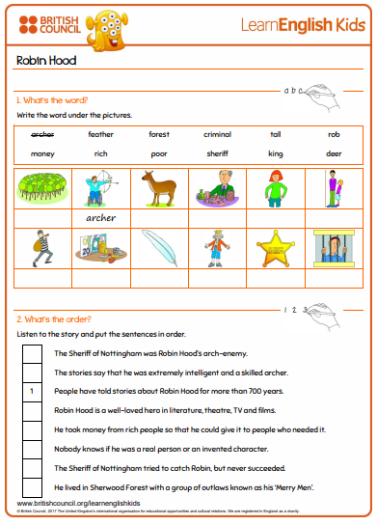

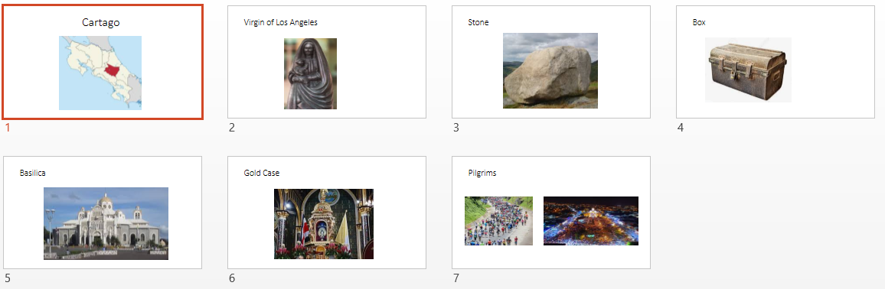

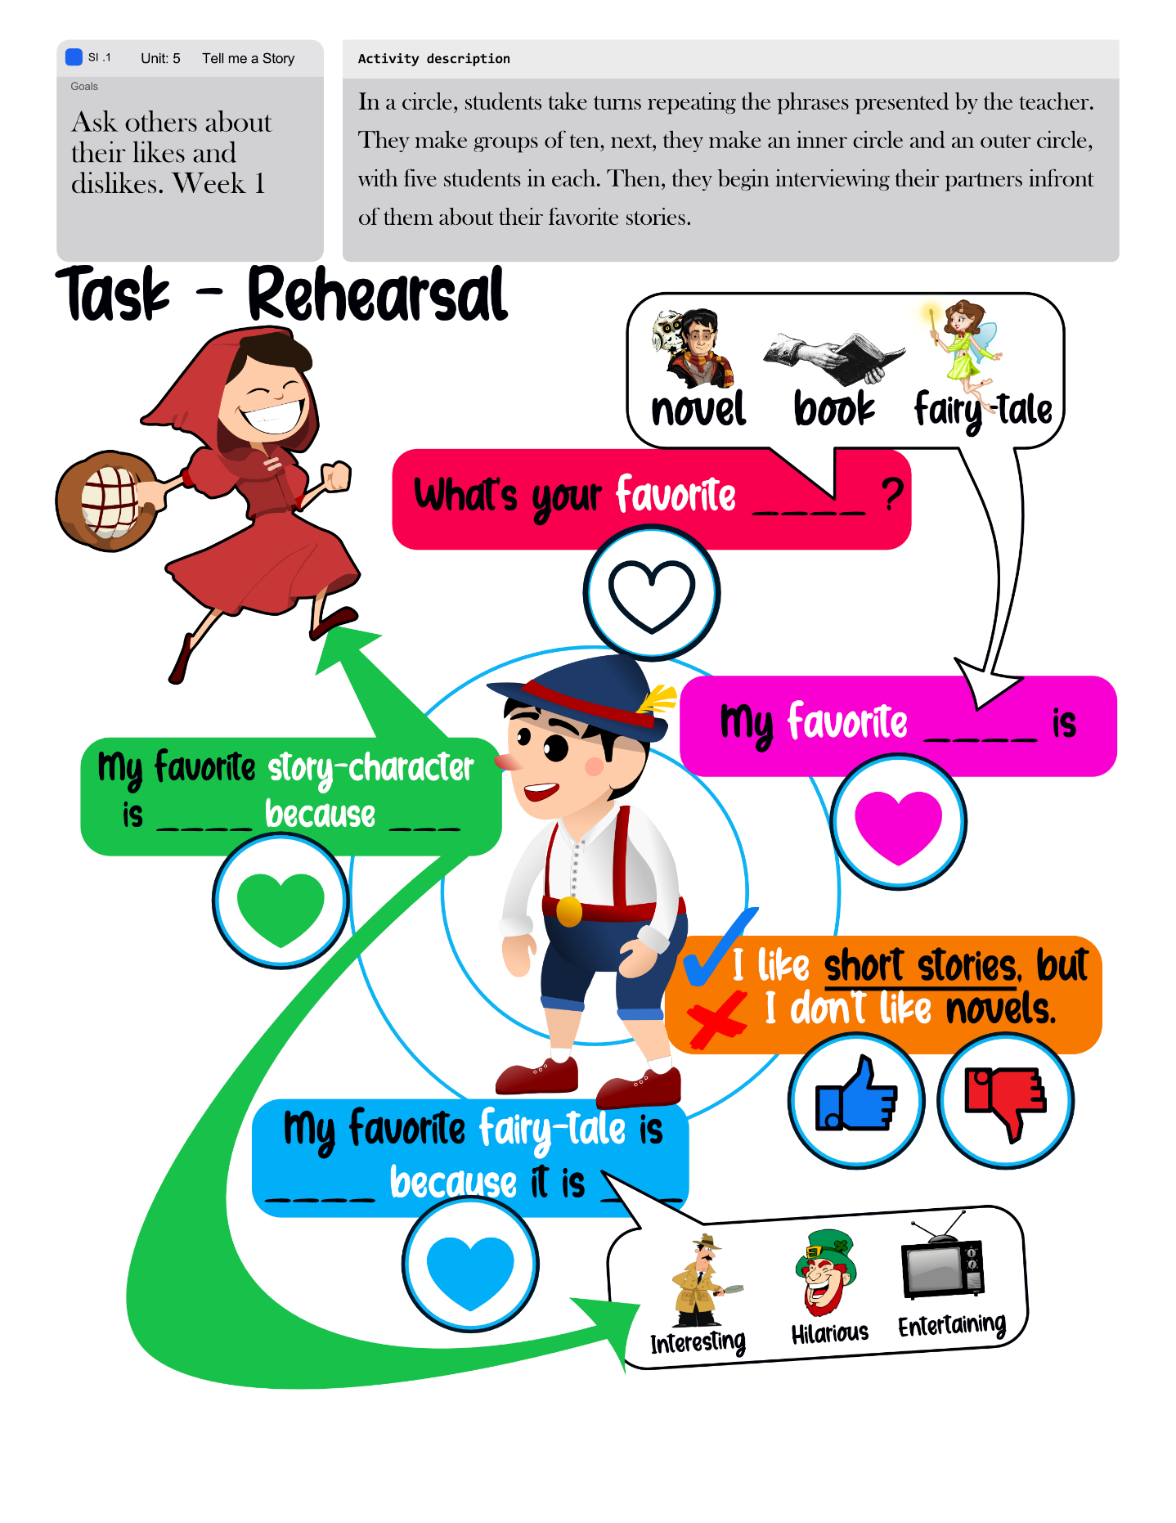

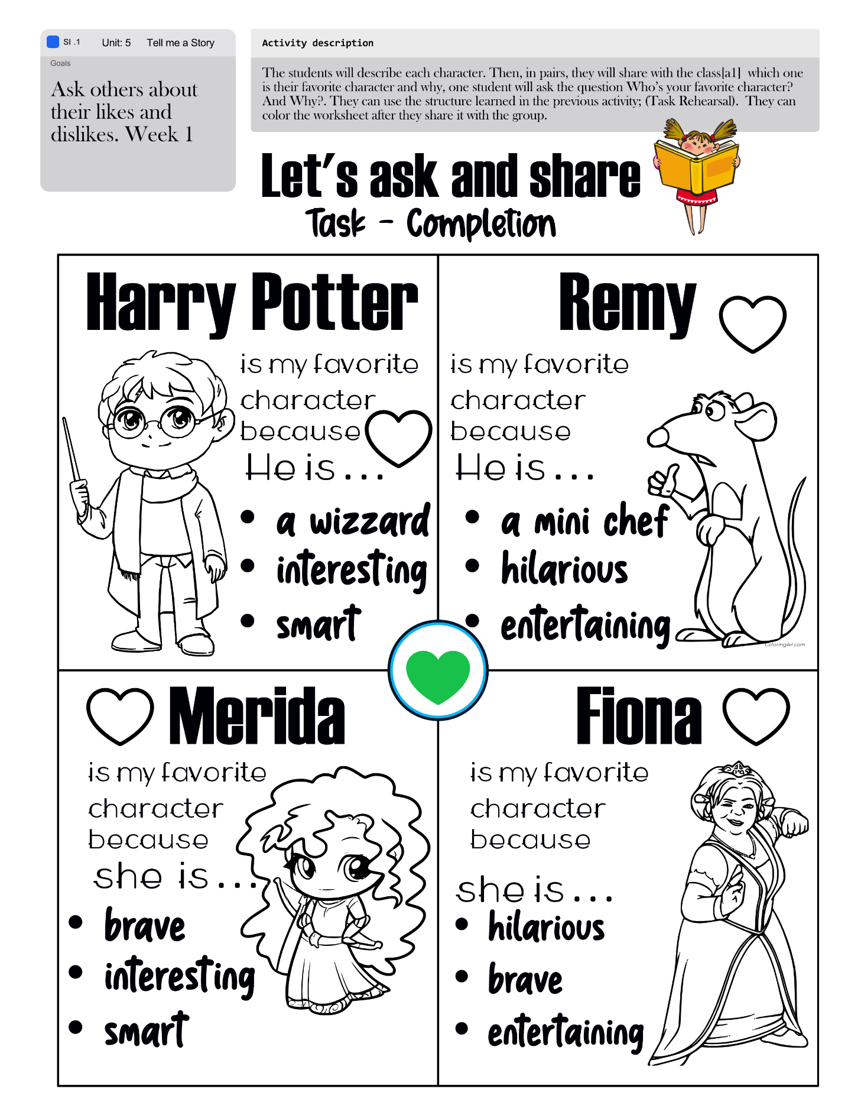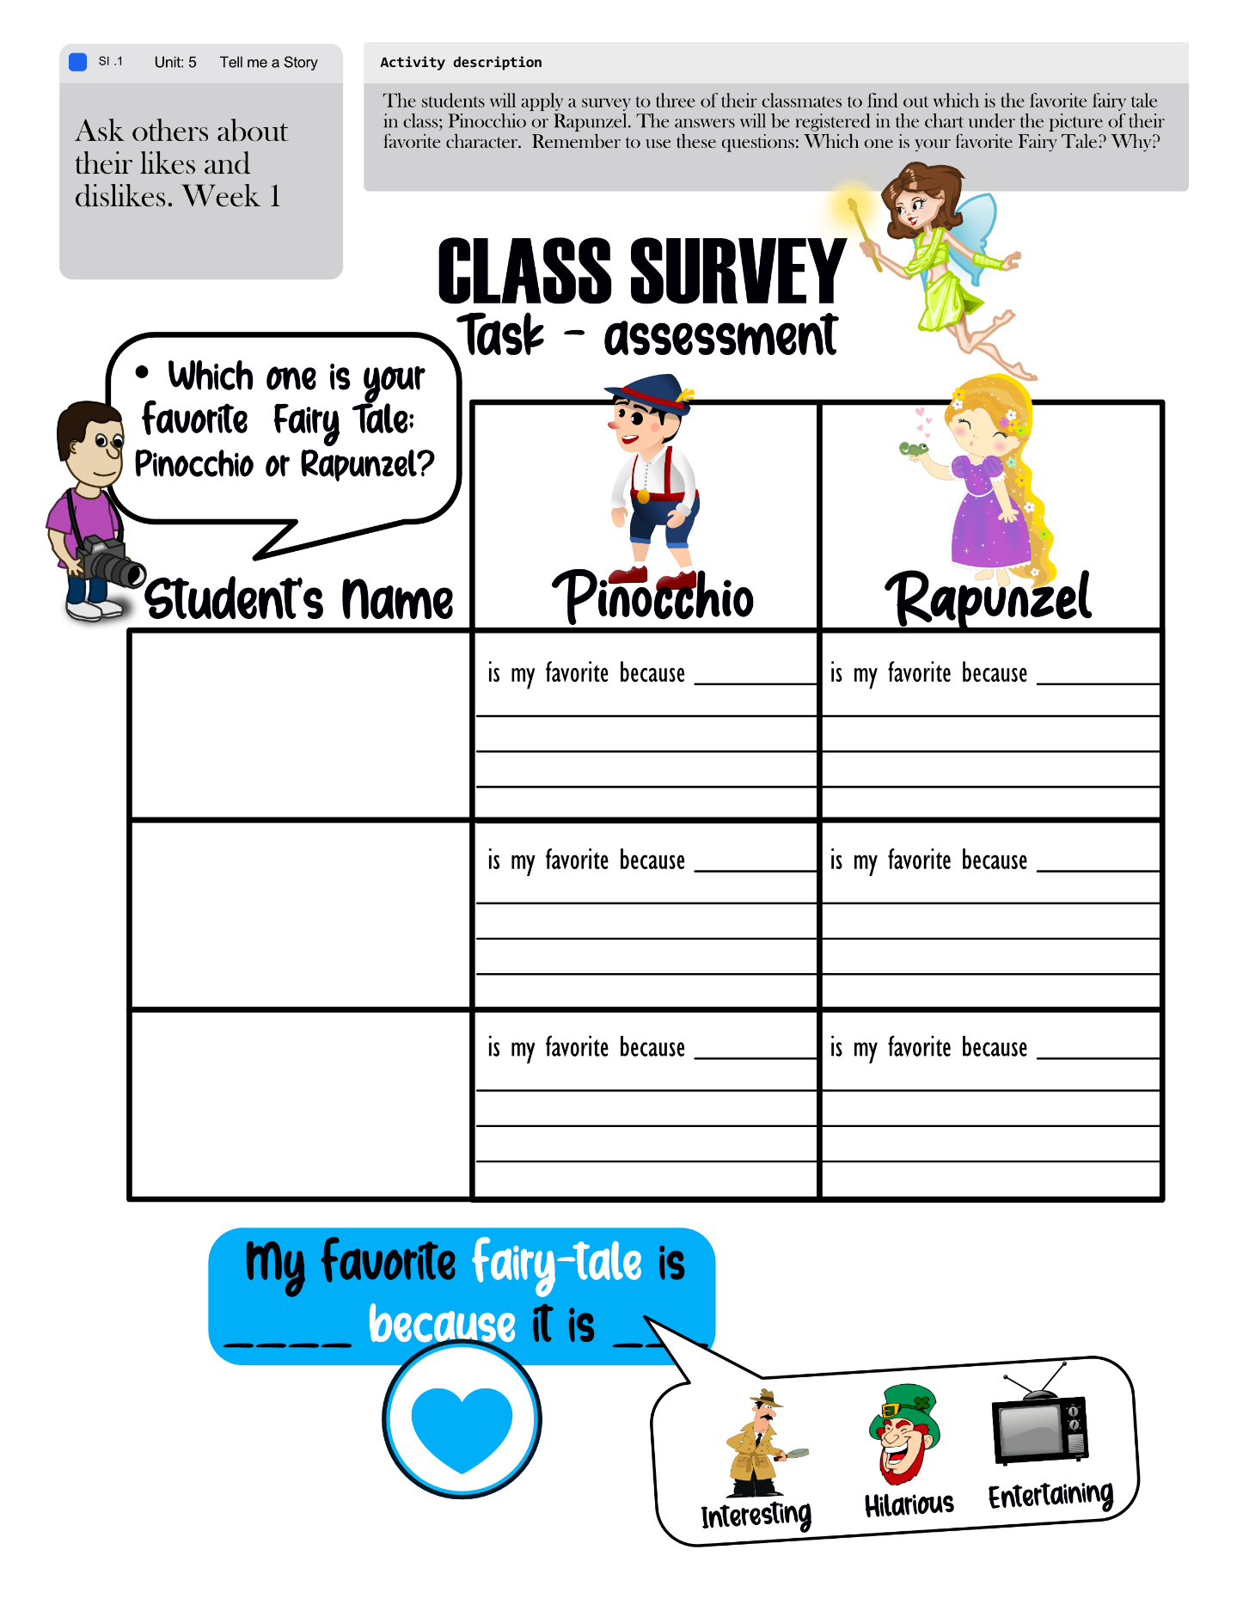

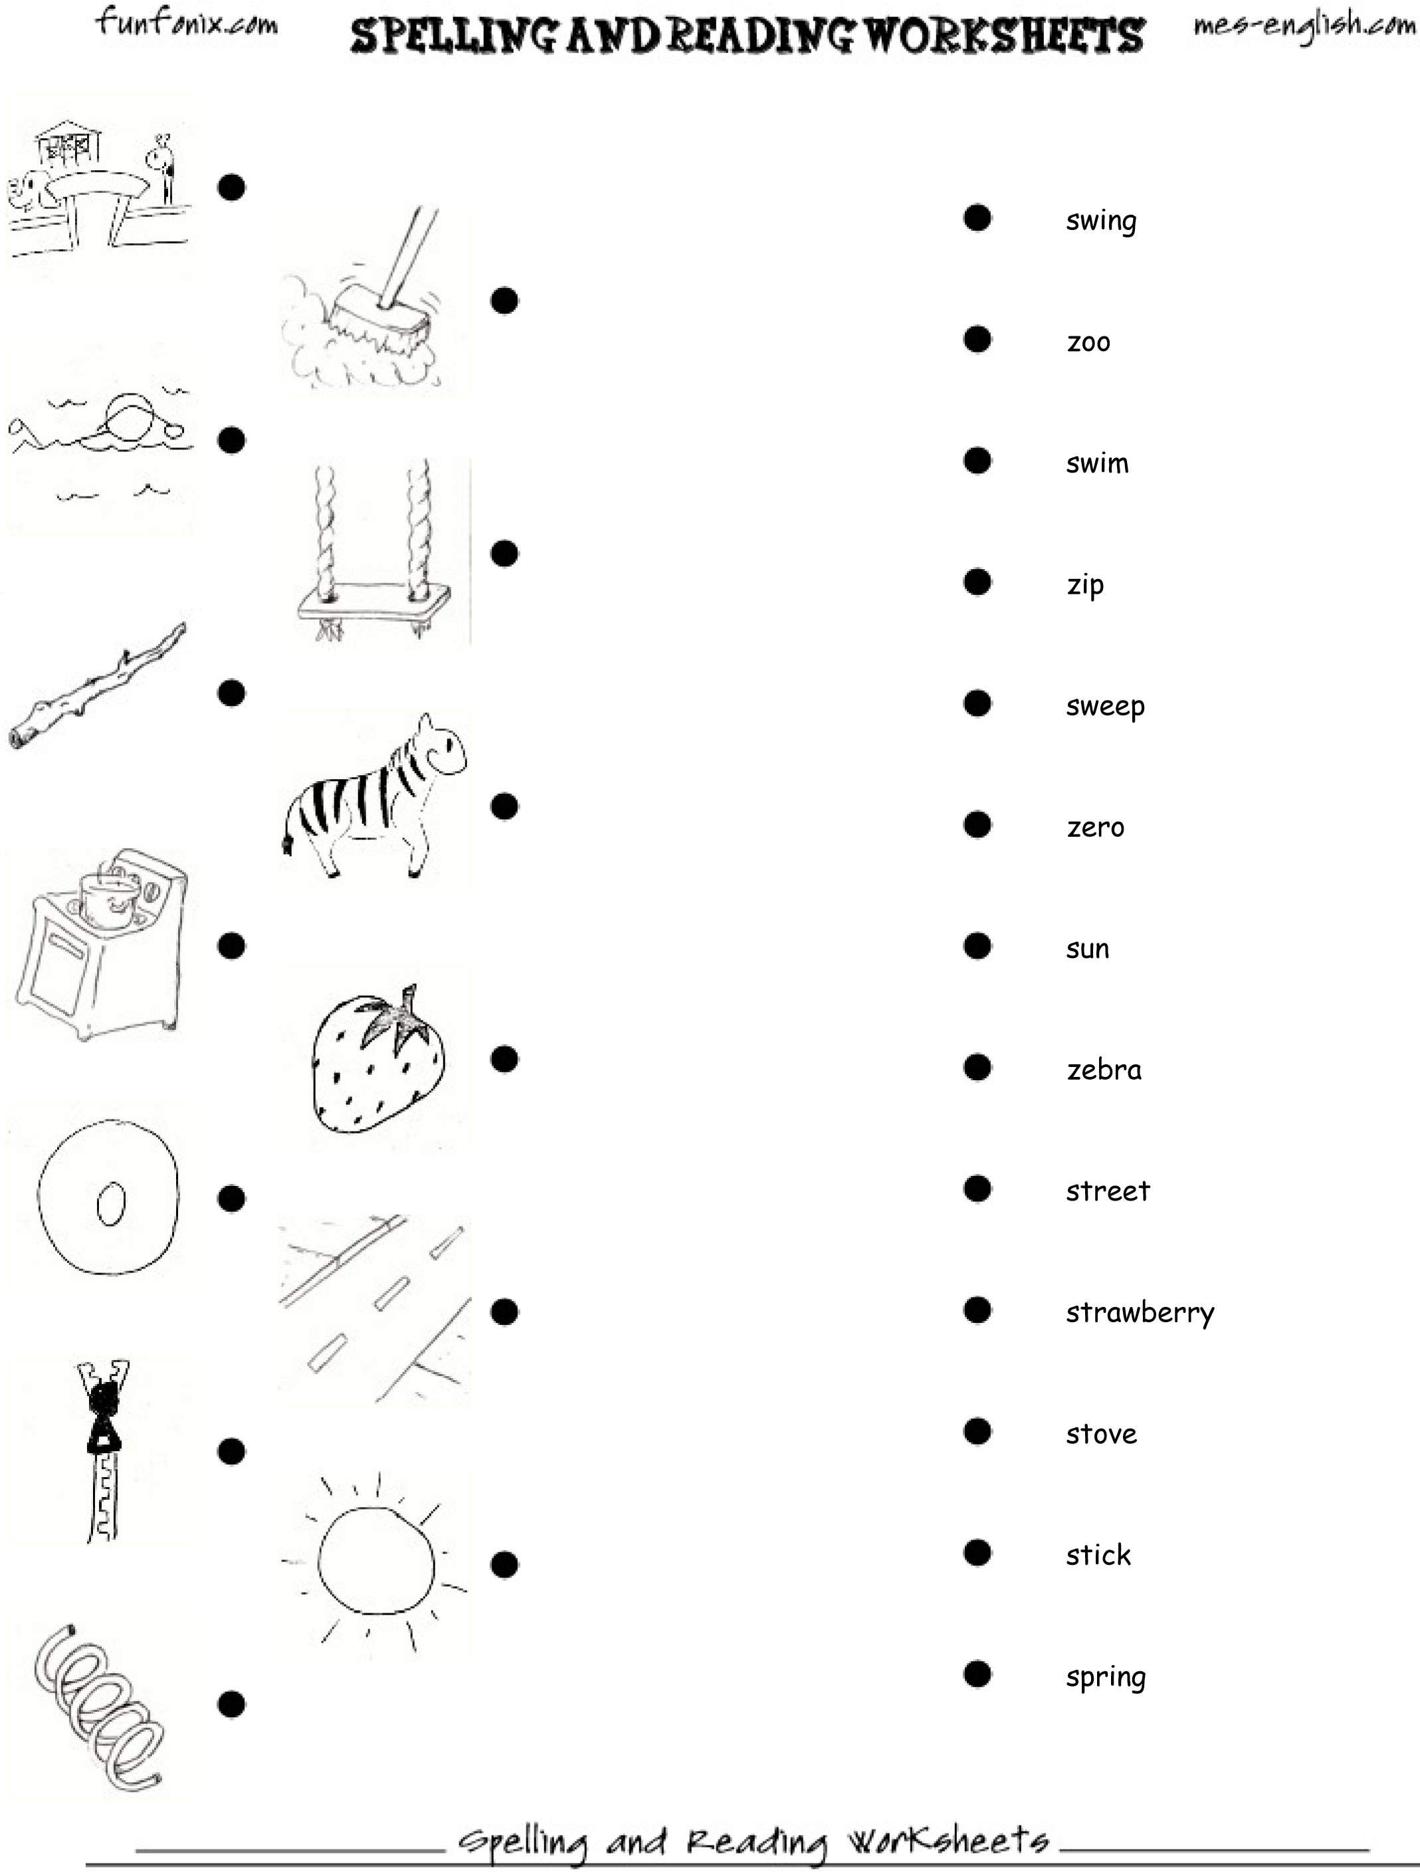

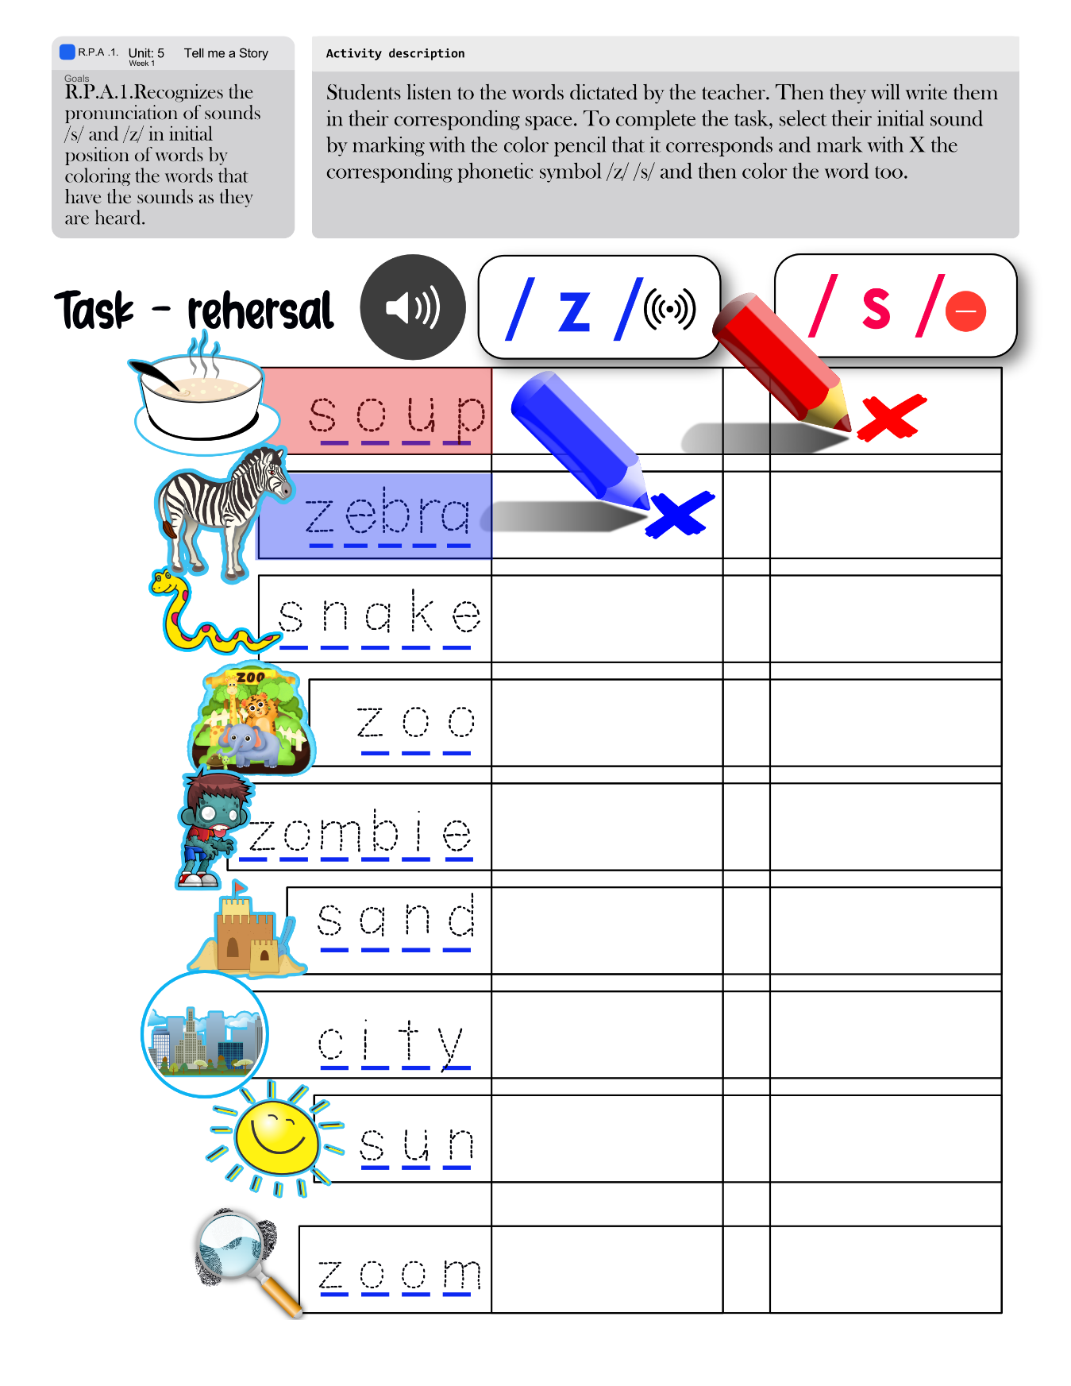

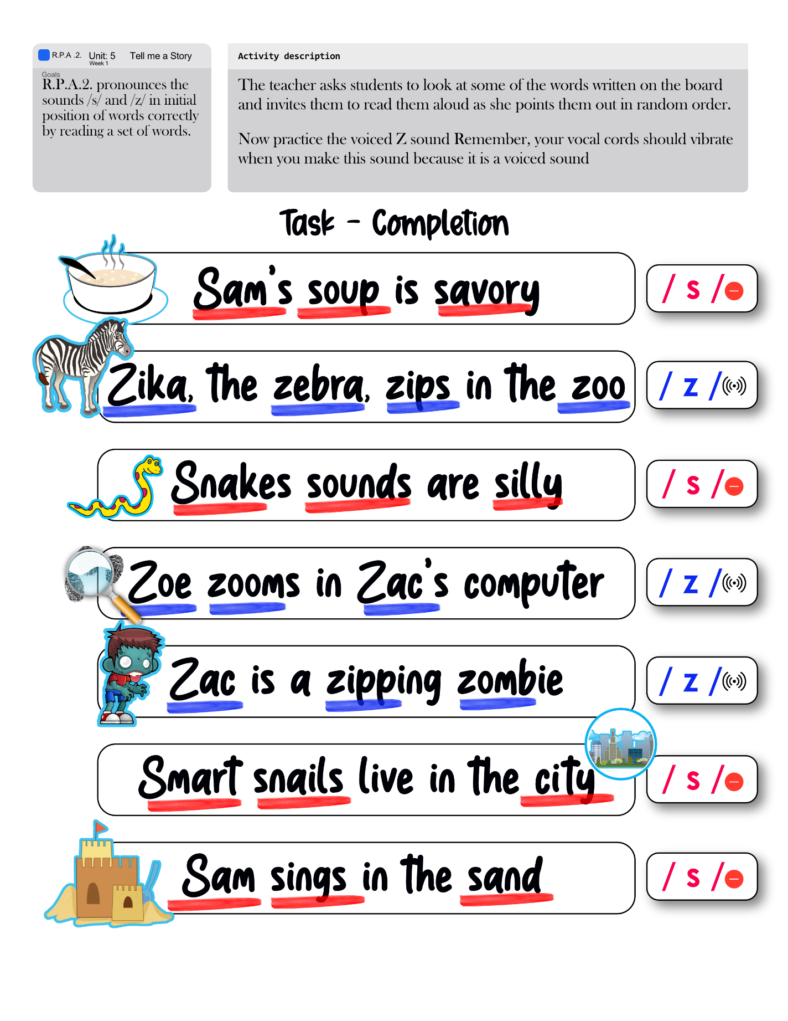

|  |  |  |  |  |  |  |  |  |  |
| --- | --- | --- | --- | --- | --- | --- | --- | --- | --- |
| **Term: III** | | **Level: Fifth Grade** | | | **Unit: 5** | | | **Week:2** | |
| **Domain: Socio-interpersonal** | | | | **Scenario: Tell me a Story** | | **Theme:** What a Wonderful Story! | | | |
| **Enduring Understanding**: A good story has characters, a setting, a plot, and a theme. There are different story genres such as fairy tales, fiction, nonfiction, poetry, legends, comics and biographies. | | | | | | | | | |
| **Essential Question:** What makes a good story? | | | | | | | | | |
| |  | | --- | | **Dimensions** | | **1.** **Ways of thinking ( X )** | | **2. Ways of living in the world  ( X )** | | **3. Ways of relating with others  ( X )** | | **4. Tools for integrating with the world  ( )** | | | | | | | | | | |
| **Learn to Know** | | | | **Learn to Do** | | **Learn to Be and Live in Community** | | | |
| **Grammar & Sentence Frames**  Present progressive   * The main character is talking about. * The man is running when he sees a tall woman next to him.   **Phonemic Awareness**  Practicing minimal pair sounds**: ŋk / ŋ**   * **think / thing** * **sank / sang** * **bank / bang** * **rink / ring** * **sunk / sung**   **Vocabulary**  2. What a wonderful story!  Expressions and phrases   * What is the story about? * Who are the main characters? * What did you like the most?   Descriptive words   * Crooked, Deep * Huge, Skinny * Bitter, Delicious * Ancient, Mean * Good   Adverbs   * Far away | | | | **Function**   * Describing setting and characters   **Discourse Markers**  Sequence adverbs-past tense  First, next, then, finally | | **Psycho-social**   * Developing a favorable attitude towards books as a way to enrich life   **Socio-cultural**   * Recognizing the importance of literature in people´s lives.   **idioms/ phrases**  Don´t count your chickens before they are hatched.= You should not count on something until it happens. | | | |
| **Assessment Strategies & Evidences of learning**  (Diagnostic, formative, summative) | **Goals** | | | **Pedagogical Mediation/ Didactic Sequence** | | | | | **Time** |
| Learner… | Learner can | | | ***CONNECTION***  **Pre-teaching**  (Teacher pastes/writes the scenario, goal and the essential question on the board)  **Warm up** Teacher will ask the students: Do you like fairy tales?After that, they answer the question she will show them a picture of Little Red Riding Hood, and she will ask them: Do you know this character?  Students will watch the video The Story of the Little Red Riding Hood - Kids Stories - LearnEnglish Kids British Council, <https://www.youtube.com/watch?v=GbzMC6qAzVU> **Activation of Prior Knowledge**  According to the story, the students will answer the following questions:   1. What is the tittle of the story? 2. Who is the main character? 3. Can you name all the characters? 4. Who is your favorite character? Why?   **Modeling**  The teacher will paste flashcards on the whiteboard, students repeat after her, and point to the draws as it corresponds.   * The words are: Crooked, Deep, Huge, Skinny, Bitter, Delicious, Ancient, Mean, Good  |  |  | | --- | --- | |  |  | |  |  | |  |  | |  |  | |  |  |   The teacher will divide the class in two teams. The teacher will place, under the flashcards, as many lines as the number of letters each word has for the students to play hangman, trying to guess the words that are represented by the pictures.  The teacher will introduce to the class the concept of far away. The teacher will explain it with the picture of the story .    ***CLARIFICATION***  **Clarifying**  Divide the class into teams (two or more if you have a large class). Then invite one student from one of the teams to come to the front of the class.  This student then has 30 seconds to act out the action words while the other students in his team guess what it is.  When students are ready, start the 30 second timer and show the student one of the flashcards / words. This student will then act out the word.  As the student is acting out the word, he/she asks his/her teammates ‘What’s he/she doing?’ As they guess, they should answer ‘He/She is (dancing).’  When they guess correctly, show the next word for the student to act out. After 30 seconds check how many words they guessed correctly.  Then it’s the other team’s turn. The team that guesses the most words correctly is the winner. | | | | | 40 minutes |
| **L2.** Recognizes phrases and high frequency vocabulary related to areas of personal interest.  **L.2.1.** identifies phrases and high frequency vocabulary related to favorite story by circling them when heard.  **L.2.2.** recognizes phrases and high frequency vocabulary about favorite book/ novel/ fairytale by matching vocabulary with pictures or by filling in blanks. | **L.2.** understand phrases and high frequency vocabulary related to areas of personal interest. | | | ***CONNECTION***  **Pre-task**  -Teacher introduces the goal of the lesson. The students will listen to the video twice [Present progressive]. What are you doing? I'm jumping. dancing. sleeping. - Easy Dialogue for Kids, at <https://www.youtube.com/watch?v=TR5RcutMu7c> The students will take notes about the activities that they know. If you do not have internet, you can read it to them. The text is located below the unit with the materials.  ***CLARIFICATION***  **Task-rehearsal**  **The teacher will ask the students the question:**   * What is the story about? * Who are the main characters? * What did you like the most? * What do you like doing?   After some of them answer the questions, they will listen to the video again and with the help of the worksheet, they will circle the actions that children are doing.   |  |  | | --- | --- | | It’s a beautiful park! | Look at the sky and trees. | | What are you doing, Jinsu? | I’m drawing trees. | | Trees are good. | Yes. I like trees. | | What are you doing, Sally? | I am jumping. | | Wow, you’re jumping high. | Wow a big fire! | | Now, come to the fire, everyone! | What are they doing? | | They are dancing. | They are good dancers | | That’s right. Let´s dance together. |  | | What is she doing? | She is sleeping. |   ***COSTRUCTION & APPLICATION***  **Task completion**  The students will make the following activity: They will listen to the video again, and they will fill in the blanks with the words in the box as they listen to them to recognize the phrases and high frequency vocabulary.   |  | | --- | | dancing – doing – drawing – jumping – She – sleeping - they – What – You |   What are you doing, Jinsu?  I’m _____________ trees.  _____________ are you doing, Sally?  I am _____________.  What are _____________ doing?  They are _____________.  What is she _____________?  _____________ is _____________.  **Task assessment**  The class will play charades. The class will be divided in two groups. A volunteer will approach the teacher that will show the students one flashcard that he has to act, and the other group will guess which word of the high frequency vocabulary is the other student acting. | | | | | 40 minutes |
| **R2.** Recognizes most of what occurs in a well-structured short story and the story’s main characters.  **R.2.1**. gets the gist of the story by answering questions.  **R2.2.** identifies the story’s main characters by completing a mind map  **R2.3.**recognizes main events in a well-structured short story by matching main events with pictures. | **R.2.** understand most of what occurs in a well-structured short story and can identify the story’s main characters. | | | ***CONNECTION***  **Pre-task**  -Teacher introduces the goal of the lesson.  Look at the front cover illustration and title and have a class discussion about what the students know about floating and sinking. Make a list of things that they think float and sink.    ***COLLABORATION***  Have the students do a think-pair-share about what they think will sink the boat and why.  ***CLARIFICATION***  **Task rehearsal**  Students read the story and then answer the questions:   * The title is a question. How do you know it is a question? * Why would the author make the title a question? * Does it spoil the ending? * What are the main characters of the story? * Which would be more likely to sink the boat? Why?  The teacher will show the students the video Who Sank The Boat at <https://www.youtube.com/watch?v=RMSCgmXHWok>, for the students to read it or give a printed copy for them to read it: If you have to read it, take into account to stop each time Pamela Allen asks “Do you know who sank the boat?” and encourage students to revise their predictions after each animal hops in the boat.   |  |  | | --- | --- | |  |  | | They decide to go for a row in the bay. |  | |  |  | | Do you know who sank the boat? |  | |  |  | |  |  | |  |  | |  |  | |  |  | |  |  | |  |  |   ***COSTRUCTION & APPLICATION***  **Task completion**  After reading the story, ask the students to work in groups of 4 and to complete the following mind map with the corresponding information:  The group will fill out the mind map all together to check it in a collaborative way.    **Task assessment**  The class will create a flip-book. They will observe the pictures, cut them and paste them on the worksheet matching the pictures with the events as it corresponds. | | | | | 40 minutes |
| **SI.2** Exchanges information about everyday matters using simple vocabulary.  **S.I.2.1** asks questions related with the content of short story or fable read in an exchange with a partner or group.  **S.I.2.1** responds to questionsrelated with the content of short story or fable read in an exchange with a partner or group. | **SI.2** exchange information about everyday matters using simple vocabulary. | | | ***CONNECTION***  **Pre-task**  -Teacher introduces the goal of the lesson.  The teacher presents the expressions that are going to be used during this week. The teacher explains the meaning of the phrases in English and tries to communicate the concept with the help of visuals and aural aids.  The students take turns to repeat the phrases and new vocabulary presented by the teacher.  ***COLLABORATION***  ***CLARIFICATION***  **Task rehearsal**  The students read story. Then, in pairs, they will ask each other questions about the story: What’s the story about? - Who are the main characters? - What did you like the most? Responds according to the story you just read. Remember to keep your distance and be safe.    ***COSTRUCTION & APPLICATION***  **Task-completion**  Students conduct a Class Poll. They register the answer to four questions about the story from the last section in this worksheet. Each student needs to interview at least three of their classmates to complete the poll. After that, the teacher will tabulate the gathered information.  .  **Task assessment**  The teacher will tabulate the results of the poll in the whiteboard. Then the students will complete the chart below by coloring each bar with the corresponding number of students who answered correctly. | | | | | 40 minutes |
| **R.P.A.**1 Shows knowledge of phonemic awareness by pronouncing sounds /ŋk / ŋ/ in final position.  **R.P.A.3**. identifies the pronunciation of sounds /nk/, / ŋ/ in final position of words by coloring the words that have the sound as they are heard.  **R.P.A.4**. pronounces the sounds /nk/ and / ŋ/ in final position of words correctly by reading a set of words or sentences. | **R.P.A.**1 demonstrate knowledge of phonemic awareness by pronouncing sounds /ŋk / ŋ/ in final position. | | | ***CONNECTION***  **Pre-task**  -Teacher introduces the goal of the lesson.  The teacher will introduce to the class the pronunciation of the sounds /ŋk / - /ŋ/ in final position by showing the students the following flashcards.   |  |  |  |  | | --- | --- | --- | --- | | * **think** |  | * **thing** |  | | * **sank** |  | * **sang** |  | | * **bank** |  | * **bang** |  | | * **rink** |  | * **ring** |  | | * **sunk** |  | * **sung** |  |   ***CLARIFICATION***  **Task-rehearsal**  The teacher will copy the words below on the whiteboard. The students will copy them, and then the teacher will pronounce some of them, and the students will identify the pronunciation of the sounds by coloring with their favorite color the words that has the /ŋk / sound in final position and the ones that have the / ŋ/ sound they will color the word with gray, as it corresponds when they hear them.   |  | | --- | | * **bang** | | * **bank** | | * **ring** | | * **rink** | | * **sang** | | * **sank** | | * **sung** | | * **sunk** | | * **thing** | | * **think** |   ***COSTRUCTION & APPLICATION***  **Task completion**  The students will write a sentence with each word. When they finish writing, they will, in a voluntary way, read one of them to the rest of the class pronouncing the words with /ŋk / - /ŋ/ in final position.  ***COLLABORATION***  **Task assessment**  The class will play a game. The students will work in pairs. They will choose a word from the vocabulary. One of them is going to tell the other one the word he/she chooses, and the other student will show the flashcard of the word he/she heard to demonstrate the knowledge of the word and its pronunciation by saying it. | | | | | 40 minutes |
| **Integrated Mini-Project** | | | | | | | | | **Time** |
| Phase: ___2____ | | | | | | | | |  |
| **Reflective Teaching** | | | | | | | | | |
| What worked well | | | What didn’t work well | | | | How to improve | | |
| **Enduring Understanding Reflection** | | | | | | | | | |
|  | | | | | | | | | |

|  |  |  |  |
| --- | --- | --- | --- |
| **Learner Self-Assessment** | | | |
| ***I can…*** | ***C:\Users\mcastilloh\Downloads\descarga.jpg***  ***No achieved yet***  (Learner cannot achieve the task) | ***C:\Users\mcastilloh\Downloads\Grinning-Face-with-Smiling-Eyes.png***  ***In progress***  (Learner can achieve the task with some difficulty and needs improvement) | ***Resultado de imagen para happy emoji***  ***Achieved***  (Learner can achieve the task without any difficulty). |
| identify phrases and high frequency vocabulary related to favorite story by circling them when heard. |  |  |  |
| recognize phrases and high frequency vocabulary about favorite book/ novel/ fairytale by matching vocabulary with pictures or by filling in blanks. |  |  |  |
| get the gist of the story by answering questions. |  |  |  |
| identify the story’s main characters by completing a mind map. |  |  |  |
| recognize main events in a well-structured short story by matching main events with pictures. |  |  |  |
| ask questions related with the content of short story or fable read in an exchange with a partner or group. |  |  |  |
| respond to questionsrelated with the content of short story or fable read in an exchange with a partner or group. |  |  |  |
| identify the pronunciation of sounds /nk/, / ŋ/ in final position of words by coloring the words that have the sound as they are heard. |  |  |  |
| pronounce the sounds /nk/ and / ŋ/ in final position of words correctly by reading a set of words or sentences. |  |  |  |

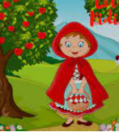

|  |  |  |
| --- | --- | --- |
|  |  |  |
|  |  |  |
|  |  |  |

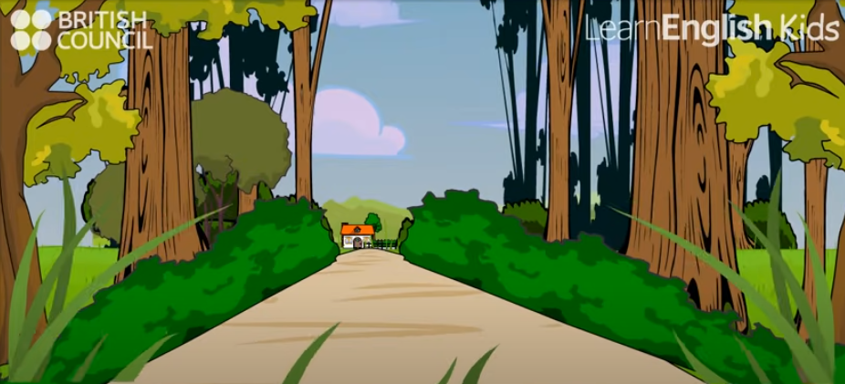

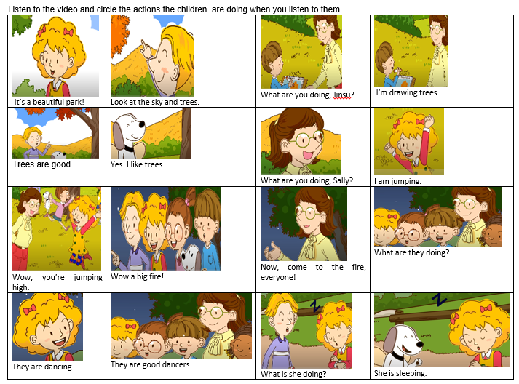

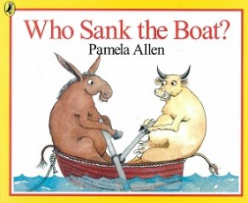

|  |  |
| --- | --- |
|  |  |
| They decide to go for a row in the bay. |  |
|  |  |
| Do you know who sank the boat? |  |
|  |  |
|  |  |
|  |  |
|  |  |
|  |  |
|  |  |
|  |  |

***COSTRUCTION & APPLICATION***

**Task completion**

Read the story, and complete the following mind map with the corresponding information:

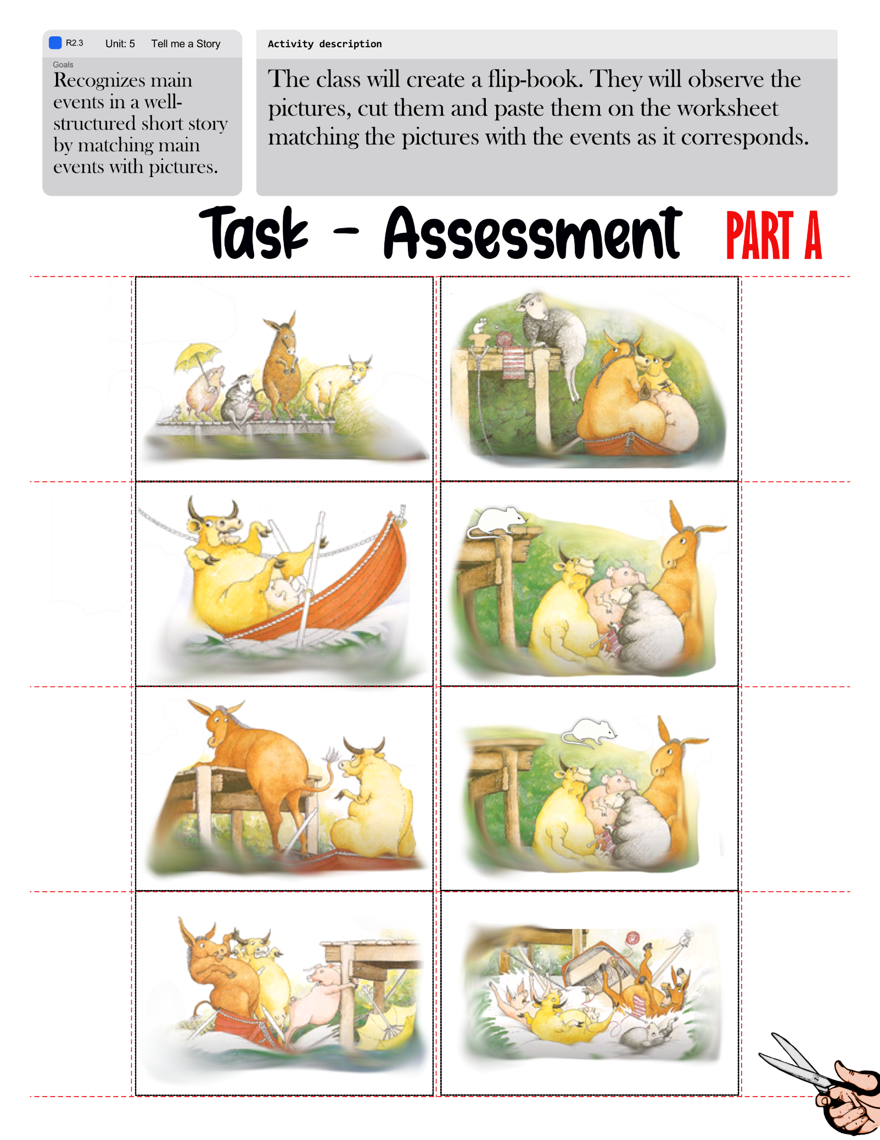

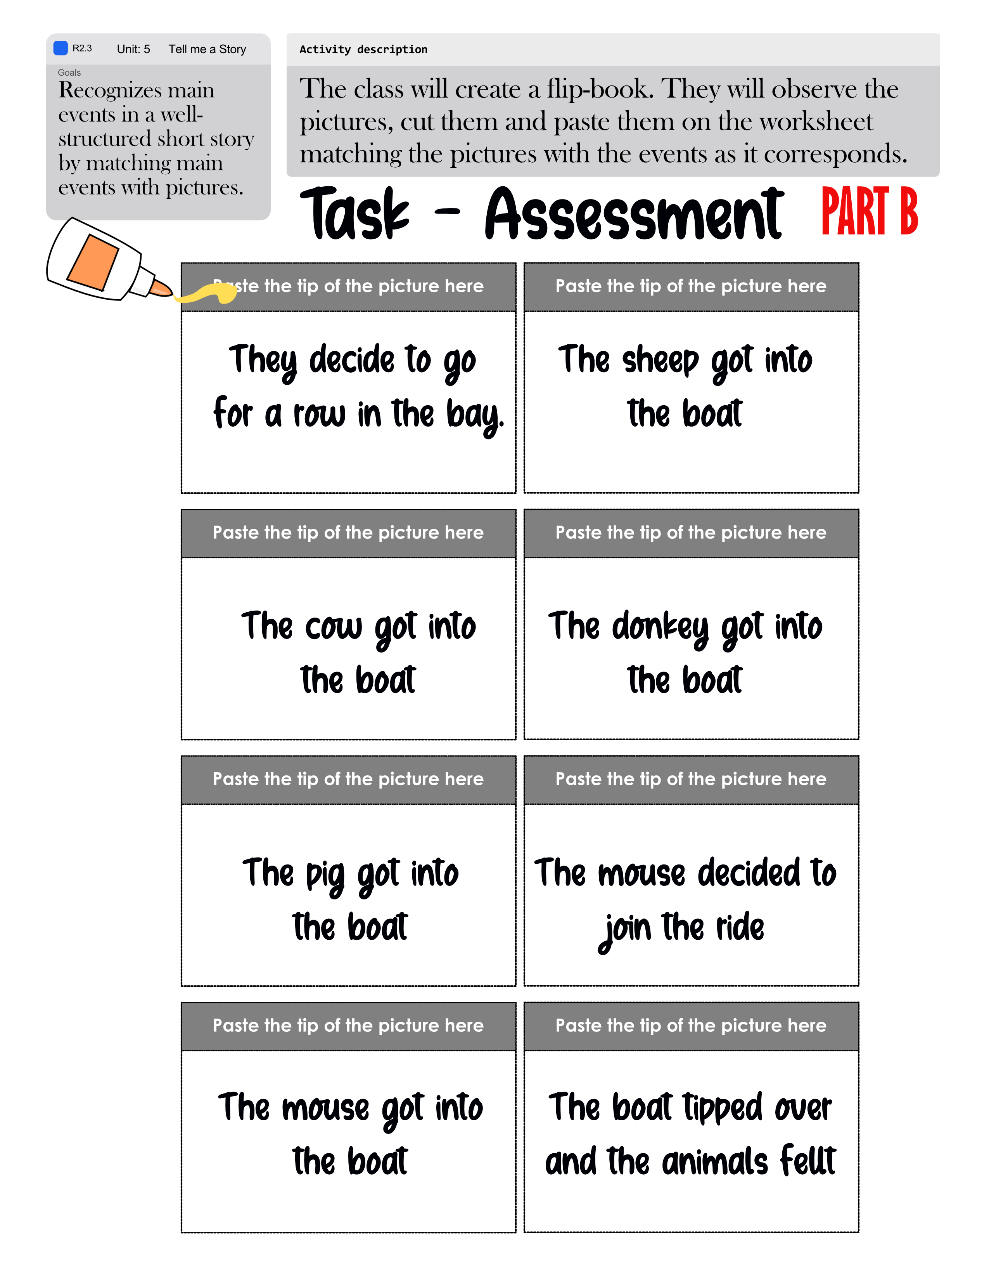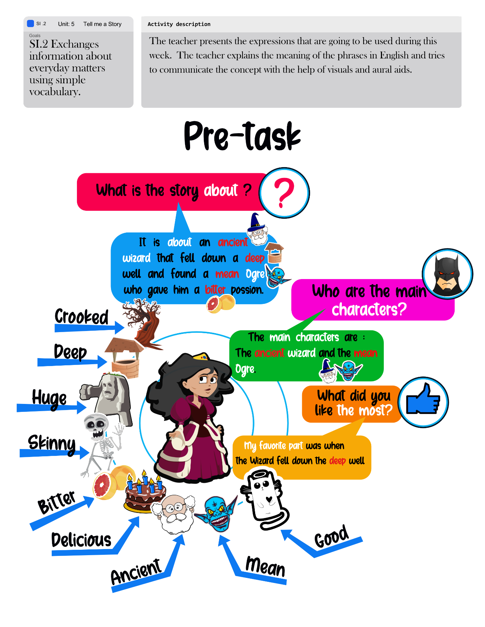

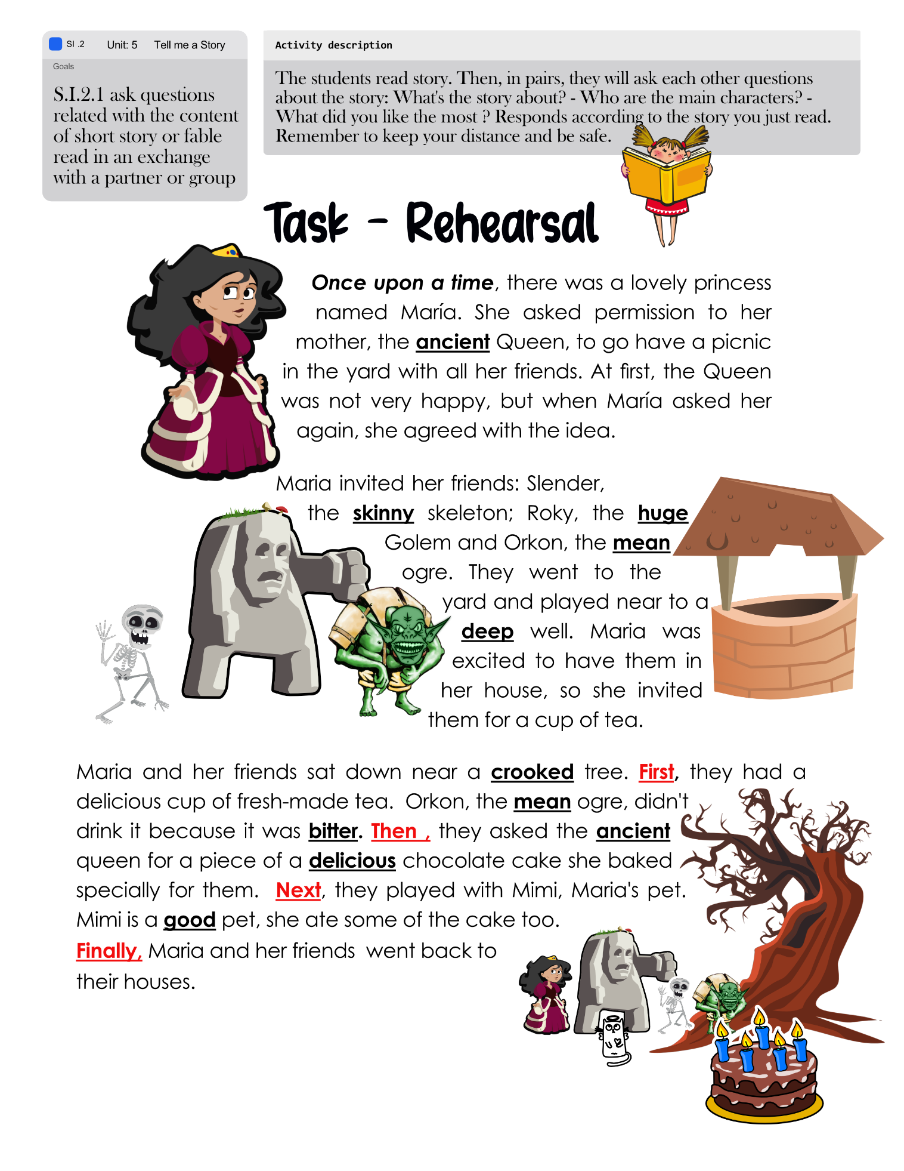

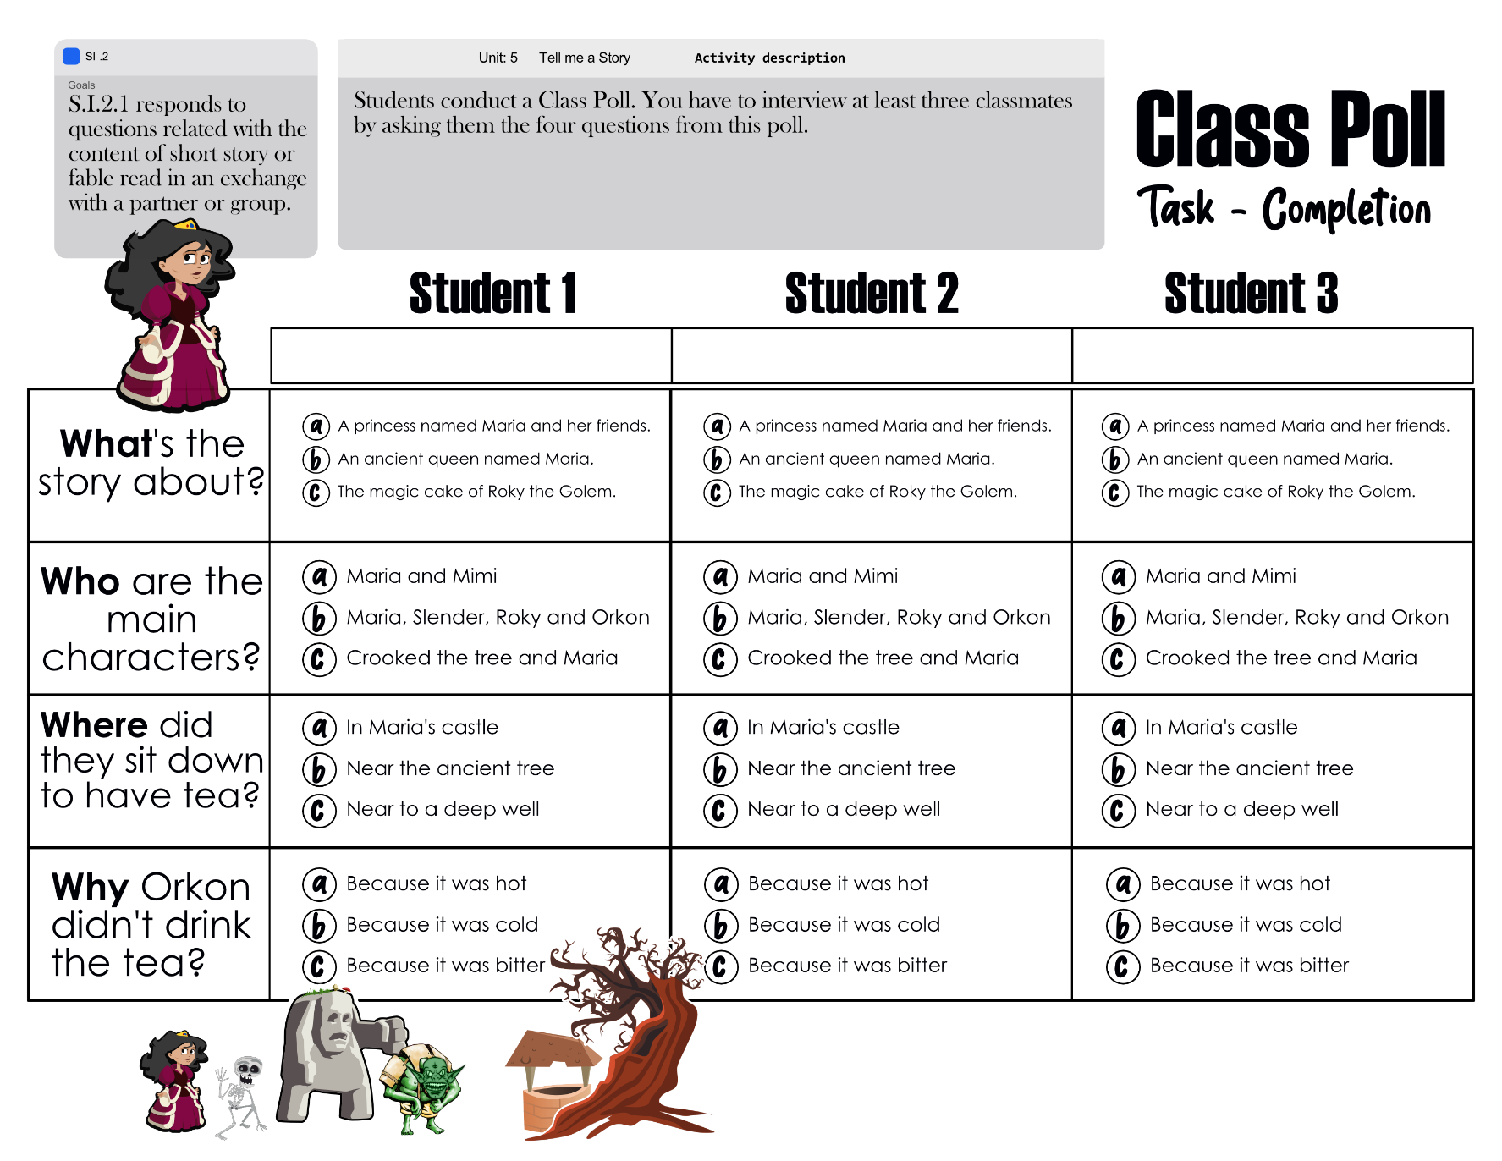

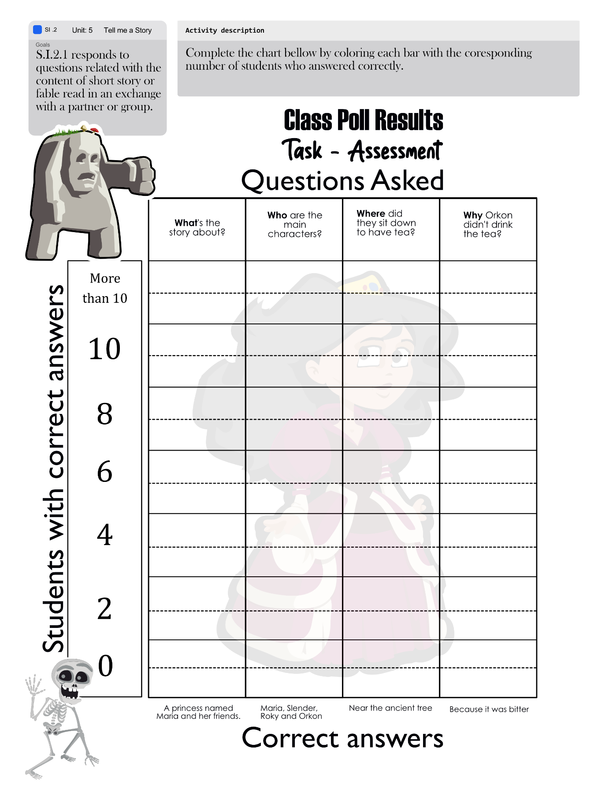

|  |  |  |  |  |
| --- | --- | --- | --- | --- |
| * **think** |  |  | * **thing** |  |
| * **sank** |  |  | * **sang** |  |
| * **bank** |  |  | * **bang** |  |
| * **rink** |  |  | * **ring** |  |
| * **sunk** |  |  | * **sung** |  |

|  |  |  |  |  |  |  |  |  |  |
| --- | --- | --- | --- | --- | --- | --- | --- | --- | --- |
| **Term: III** | | **Level: Fifth Grade** | | | **Unit: 5** | | | **Week:3** | |
| **Domain: Socio-interpersonal** | | | | **Scenario: Tell me a Story** | | **Theme:** Acting It Out | | | |
| **Enduring Understanding**: A good story has characters, a setting, a plot, and a theme. There are different story genres such as fairy tales, fiction, nonfiction, poetry, legends, comics and biographies. | | | | | | | | | |
| **Essential Question:** What makes a good story? | | | | | | | | | |
| **Learn to Know** | | | | **Learn to Do** | | **Learn to Be and Live in Community** | | | |
| **Grammar & Sentence Frames**  Present perfect   * The three men have lived in the house for many years. * The child has not done the bed yet.   **Phonemic Awareness**  Practicing digraphs   * **(th, sh)** * **think, teeth,** * **she, shield**   **Vocabulary**  3.Acting it out  Expressions and phrases   * What´s my role? * What should I do? * Who goes first, second? * When is my turn?   Actions   * vary tone and volume of voice * Express your emotions ( anger, delight, surprise, worry, fear) * Dress costumes * Use body language, miming and gesturing * Use pauses * Elicit and ask questions * Let´s put some special effects with sounds | | | | **Function**   * Describing the main events in a story   **Discourse Markers**  Sequence adverbs-past tense  First, next, then, finally | | **Psycho-social**   * Stimulating and expanding creativity and imagination   **Socio-cultural**   * Gaining multiple cultural perspectives through the reading of literature pieces   **idioms/ phrases**  She found her prince charming. = She found her ideal mate. | | | |
| **Assessment Strategies & Evidences of learning**  (Diagnostic, formative, summative) | **Goals** | | | **Pedagogical Mediation/ Didactic Sequence** | | | | | **Time** |
| Learner… | Learner can | | | ***CONNECTION***  **Pre-teaching**  (Teacher pastes/writes the scenario, goal and the essential question on the board)  **Warm up**  The teacher will play with the students a guessing game in order to introduce the vocabulary they are going to use this week, so she/he will show the students a flashcard representing any of the following emotions (anger, delight, surprise, worry, fear, happiness), and the students will guess which is the feeling, and they will make a sentence with that feeling and write it on the whiteboard. Later, they will write them in their notebooks.  **Activation of Prior Knowledge**  Using the flashcards of the story, Who Sank the Boat? The students will retell the main events of the story to review aspects such as characters and description of setting.  **Modeling**  The teacher will present to the class a chart with the following information:  **Adverbs of Sequence. The order in which things happen in a story.**  The students will talk about moments in which they have listened to these adverbs. They will try to share examples with their classmates.  Also, the teacher will introduce the meaning of “plot”. She/He will explain that it is about what happens on a story, and the students will talk about a story that they like, and they will explain what the plot of their favorite story is in their words.  The teacher will give to the students the receipt for “Agua Dulce”  How to make a cup of Agua Dulce  First, we boil some water.  Next, serve the water in a cup.  Then, put two tablespoons of “Tapa de Dulce”.  After, add some milk.  Finally, add a biscuit and enjoy it!  ***CLARIFICATION***  **Clarifying**  The teacher will read to the students the following information:  Adverbs of sequence  We use adverbs of sequence to describe the order in which things happen. We often use them to tell a story, write a recipe or give directions. They usually come at the beginning of a sentence, and they are followed by a comma (,).  The teacher will ask the students to order the following sentences by writing the number on the blank line next to them. | | | | | 40 minutes |
| **SP.1.** Describes basic aspects of a story, fairy tale or fable.  **SP.1.1.**identifies the basic aspects of a story, fairy tale or fable such as plot and main characters when supported by pictures, drawings or a mind map using basic vocabulary and phrases.  **SP.2.1.** retells the basic events of a story, fairy tale or fable such as main characters and plot when supported by pictures, drawings or a mind map using simple sentences. | **SP.1.** describe basic aspects of their day-by-day life, such as favorite foods and daily activities. | | | **Pre-task**  -Teacher introduces the goal of the lesson.  The teacher will ask the students to observe some flashcards and to try to guess what they are related to.    Walk the dogs  As soon as they realize that it is something related with daily aspects, the teacher can read to the students the story “The daily routine of the Queen”    ***CLARIFICATION***  **Task-rehearsal**  The class will identify basic aspects form the story by answering to questions with the help of the picture, such as:  What is the plot of the story?  Who is the main character of the story?  Which are other characters of the story  Is the Queen happy?  After that, the students will work in groups. Each group will retell the basic events of the story they heard with the help of drawings that they will prepare and using simple sentences. The sentences should be in order, as they correspond with the drawings. Students should use first, next and so on, for example:    First, the Queen eats breakfast.  ***COSTRUCTION & APPLICATION***  **Task completion**  Each group will present their work of retelling the story to the class, with the help of the drawings that they made.  **Task assessment**  Working in groups, the students will prepare an oral presentation with the aid of a poster. Each group will use the poster to describe basic aspects of their day life, using their daily activities and their favorite foods. For the poster, they can reuse old newspapers or magazines to illustrate it. | | | | | 40 minutes |
| **W1.** Writes, with the help of illustrations, a little short story or fairy tale.  **W.1.1.**brainstorms main ideas of favorite story or fairy tale as a form of pre-writing.  **W.1.2.** makes an outline to organize the main ideas of favorite story or fairy tale using phrases and simple sentences.  **W.1.3.** makes a draft of text by writing complete sentences for each main idea connected with liking words such as… next, then, after, finally with the help of illustrations.  **W.1.4.** edits a text of a short story or fairy tale supported with pictures or drawings by checking for correct grammar, spelling, punctuation and capitalization. | **W.1.** write a short text with the help of illustrations, a little short story or fairy tale. | | | ***CONNECTION***  **Pre-task**  The teacher shares the goal of the lesson.  Learners watch the video[**https://www.youtube.com/watch?v=dT9ZeKwbVhk**](https://www.youtube.com/watch?v=dT9ZeKwbVhk)  [#EnglishFairyTalesChannel](https://www.youtube.com/hashtag/englishfairytaleschannel) The Hardworking Confectioner Story in English | Stories for Teenagers | English Fairy Tales  In this way, students will recognize the main idea and understand a bit more about the parts of a short story, its plot and characters.  ***CLARIFICATION***  **Task-rehearsal**  The teacher will tell the class that they are going to brainstorm ideas about their favorite story, and the teacher will write down the ideas on the whiteboard  First they have to think of an idea ( it can be something they read about, a story or a fairy tale or some real-life experiences such as your daily routines, or your favorite food)  Students will make an outline where they can organize the main ideas, with simple sentences and ordering the characters, ***COSTRUCTION & APPLICATION*****Task completion** According to the previous ideas that the students drafted, the teacher will give the students some images. If the teacher wants, he/she can use the examples, and the students will write their short story.   |  |  |  | | --- | --- | --- | |  |  |  | |  |  |  | |  |  |  |   For example,  My Daily Routines  What do you do on a school day? Write a short story using first, then, after that, next and finally. You can start like this:  First, I __________________________ at__________________________.  ***COLLABORATION***  In pairs, students will check each other’s story, by paying special attention to spelling, grammar, punctuation and capitalization of words. When they check their works, the teacher will help them to finish the edition.  **Task assessment**  The students will share their stories in a wall board, so they can read each other’s works, in a safe and respectful way. | | | | | 40 minutes |
| **R.P.A.1** Shows knowledge of phonemic awareness by pronouncing sounds the diagraphs (th, sh) in initial position.  **R.P:A.5**. identifies the pronunciation of the diagraphs (th, sh, ph) in initial position by circling the words that have the diagraphs as they are heard. | **R.P.A.1** demonstrate knowledge of phonemic awareness by pronouncing sounds the diagraphs (th, sh) in initial position. | | | ***CONNECTION***  **Pre-task**  -Teacher introduces the goal of the lesson.  The class will observe the video: Voiceless Diagraph /th/ Sound – Phonics by TurtleDiary at: <https://www.youtube.com/watch?v=Ih55yasmR-Q>  then they will observe the video : Digraph /sh/ Sound – Phonics by TurtleDiary at: <https://www.youtube.com/watch?v=ptfu3tL0OBg> The class will watch the video The PH Sound | Phonics Video | Scratch Garden [http://bit.ly/ph-sound](http://bit.ly/ph-sound%20).  After watching the video [http://bit.ly/ph-sound](http://bit.ly/ph-sound%20) suggested by the teacher, students identify a set of different words that have the /ph/ sound in their initial syllable.  ***CLARIFICATION***  **Task-rehearsal**  The teacher will paste or copy the poster on the board.   |  |  | | --- | --- | | **/th/** | **/sh/** | | Thumb: The baby is sucking his thumb. | Ship: Stop! Shout out to the big ship in the sea. | | Thorn: Be careful with the thorn on the rose! | Shop: Let´s find out what our friends got from the toy shop! | | Thread: It is a green thread. | Sheep: I love the black sheep. | | Thick: The book is thick. | Shell: The shell is on the sand. | | Throw: Throw me the ball | Shoe: I lost one black shoe. | | Think: Think on me! | Shark: The shark is a beautiful animal. | | Mouth: I have a nice mouth. | She: She is my mother. | | Bath: I take a bath. | Shield: Wonder Woman has a shield. | | Cloth: I have a cloth. |  |   The teacher will read the words and the sentences twice. And she/he will have the flashcards that represent the words that have the diagraphs /th/ and /sh/.  The students will repeat the words and the sentences after the teacher.  After watching the videos suggested to the teacher, students identify a set of different words that have the /ph/ sound in their initial syllable. Put the words under their corresponding sound.    ***COSTRUCTION & APPLICATION***  **Task completion**  Unscramble the following words, then read them and write them under the sound as it corresponds:  arskh: _______________________  kihtn: _______________________  nhepo: _______________________  wrhot: _______________________  epehs: _______________________  otohp: _______________________   |  |  |  | | --- | --- | --- | | **/th/** | **/sh/** | **/ph/** | |  |  |  | |  |  |  | |  |  |  | |  |  |  | |  |  |  | |  |  |  |   **Task assessment**  The teacher will give the students a worksheet with pictures that represents words with the sounds /th/, /ph/ and /sh/ in initial position. She will read the sentences, and the students will circle the sentence that they hear as it corresponds.   |  |  | | --- | --- | |  | The cell is beautiful.  The shell is beautiful. | |  | The man is thinking.  The man is ticking. | |  | There are tree.  There are three. | |  | She has a child.  Chee has a shield. | |  | It’s a lovely photo.  It’s a lovely moto. | |  | She has a child.  She has a shield. | |  | Mom has a phone.  Mom has a cone. | | | | | | 40 minutes |
| **Integrated Mini-Project** | | | | | | | | | **Time** |
| Phase: _______ | | | | | | | | |  |
| **Reflective Teaching** | | | | | | | | | |
| What worked well | | | What didn’t work well | | | | How to improve | | |
| **Enduring Understanding Reflection** | | | | | | | | | |
|  | | | | | | | | | |

|  |  |  |  |
| --- | --- | --- | --- |
| **Learner Self-Assessment** | | | |
| ***I can…*** | ***C:\Users\mcastilloh\Downloads\descarga.jpg***  ***No achieved yet***  (Learner cannot achieve the task) | ***C:\Users\mcastilloh\Downloads\Grinning-Face-with-Smiling-Eyes.png***  ***In progress***  (Learner can achieve the task with some difficulty and needs improvement) | ***Resultado de imagen para happy emoji***  ***Achieved***  (Learner can achieve the task without any difficulty). |
| identify the basic aspects of a story, fairy tale or fable such as plot and main characters when supported by pictures, drawings or a mind map using basic vocabulary and phrases. |  |  |  |
| retell the basic events of a story, fairy tale or fable such as main characters and plot when supported by pictures, drawings or a mind map using simple sentences. |  |  |  |
| brainstorm main ideas of favorite story or fairy tale as a form of pre-writing. |  |  |  |
| make an outline to organize the main ideas of favorite story or fairy tale using phrases and simple sentences. |  |  |  |
| make a draft of text by writing complete sentences for each main idea connected with liking words such as… next, then, after, finally with the help of illustrations. |  |  |  |
| edit a text of a short story or fairy tale supported with pictures or drawings by checking for correct grammar, spelling, punctuation and capitalization. |  |  |  |
| identify the pronunciation of the diagraphs (th, sh, ph) in initial position by circling the words that have the diagraphs as they are heard. |  |  |  |

**Adverbs of Sequence, the order in which things happen in a story**

How to make a cup of Agua Dulce 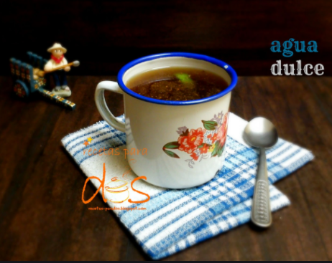

First, we boil some water. 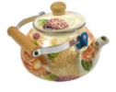

Next, serve the water in a cup. 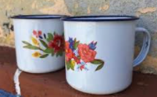

Then, put two tablespoons of “Tapa de Dulce”. 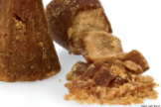

After, add some milk. 

Finally, add a biscuit and enjoy it! 

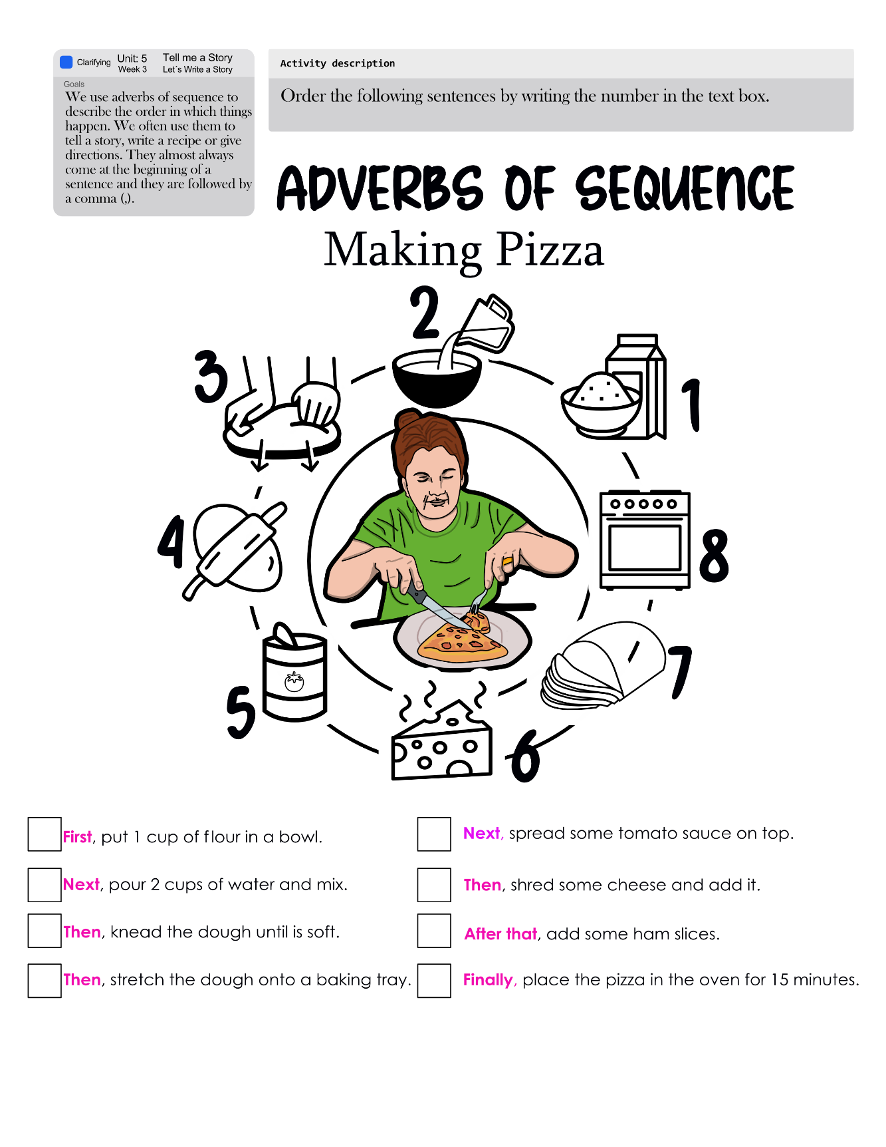

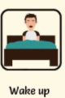 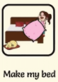 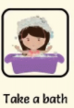 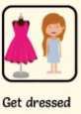

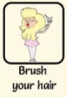 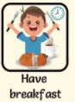 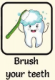 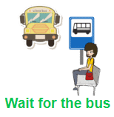

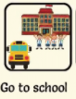 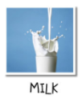 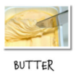 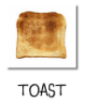

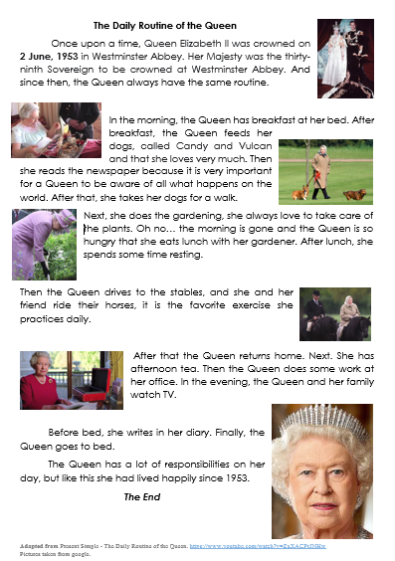

|  |  |  |
| --- | --- | --- |
|  |  |  |
|  |  |  |
|  |  |  |

Images taken from <https://sp.depositphotos.com/vector-images/rutina-diaria.html>

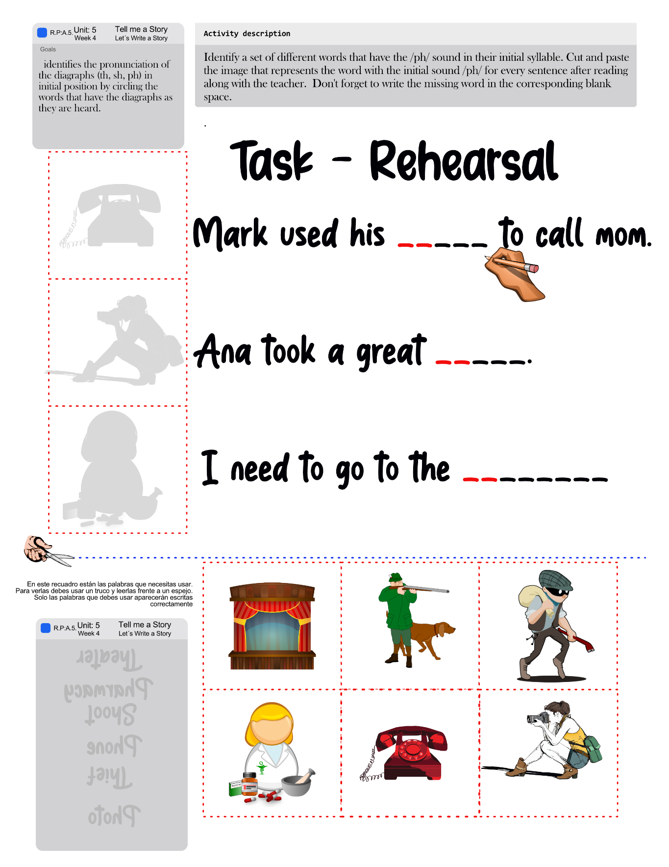

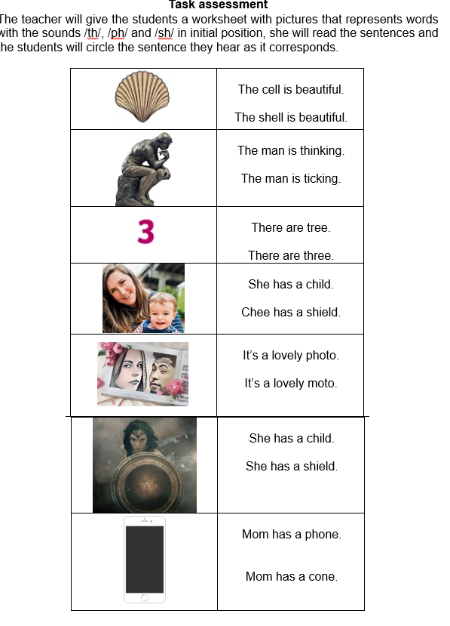t

|  |  |  |  |  |  |  |  |  |  |
| --- | --- | --- | --- | --- | --- | --- | --- | --- | --- |
| **Term: III** | | **Level: Fifth Grade** | | | **Unit:5** | | | **Week:4** | |
| **Domain: Socio-interpersonal** | | | | **Scenario: Tell me a Story** | | **Theme:** Let´s Write a Story | | | |
| **Enduring Understanding**: A good story has characters, a setting, a plot, and a theme. There are different story genres such as fairy tales, fiction, nonfiction, poetry, legends, comics and biographies. | | | | | | | | | |
| **Essential Question:** What makes a good story? | | | | | | | | | |
| |  | | --- | | **Dimensions** | | **1.** **Ways of thinking ( X )** | | **2. Ways of living in the world  ( X )** | | **3. Ways of relating with others  ( X )** | | **4. Tools for integrating with the world  ( X )** | | | | | | | | | | |
| **Learn to Know** | | | | **Learn to Do** | | **Learn to Be and Live in Community** | | | |
| **Grammar & Sentence Frames**  Simple Past   * One upon a time, there was/were ____. * The story was about _____.   Interrogative past sentences beginning with “What.”; "Where"; "Who”   * Where did the story take place? * What was the story about?   Who felt sad in the story?  **Phonemic Awareness**  Practicing digraphs   * **(ph)** * **phone, photo**   **Vocabulary**  4.Let´s write a story  Parts of a story   * Characters, setting, plot, conflict   Descriptive Adjectives   * attractive, adorable,   Story characters   * dragon, witch, princess   Transition words, connectors, sequence words  Then, furthermore, after, finally | | | | **Function**   * Describing past events   **Discourse Markers**  Sequence adverbs-past tense  First, next, then, finally | | **Psycho-social**   * Stimulating and expanding creativity and imagination.   **Sociocultural**   * Gaining multiple cultural perspectives through the reading of literature pieces   **idioms/ phrases**  She cried crocodile tears. = She cried fake tears. | | | |
| **Assessment Strategies & Evidences of learning**  (Diagnostic, formative, summative) | **Goals** | | | **Pedagogical Mediation/ Didactic Sequence** | | | | | **Time** |
| Learner… | Learner can | | | ***CONNECTION***  **Pre-teaching**   * Teacher introduces the goal of the lesson.   Routine: Checking attendance, checking in with Ls, T posts the Essential Question, goal, Can Do’s, and class agenda, etc. on the board  **Warm up**  Teacher presents the video [**http://bit.ly/the-main-idea**](http://bit.ly/the-main-idea) , and asks learners to take notes on what is being said in the video.  **Activation of Prior Knowledge**  **Modeling**  The teacher uses the previous activity to model the answer to the following questions:    ***CLARIFICATION***  **Clarifying**  The teacher goes through the previous exercise while explaining the relation between each question and the parts of the story. | | | | | 40 minutes |
| **SI.2** Exchanges information about everyday matters using simple vocabulary.  **S.I.2.1** asks questions related with the content of short story or fable read in an exchange with a partner or group.  **S.I.2.1** responds to questions related with the content of short story or fable read in an exchange with a partner or group. | **SI.2** exchange information about everyday matters using simple vocabulary. | | | **Pre-task**   * Teacher introduces the goal of the lesson. * Teacher shows this infographic to students. Teacher describes the process of identifying the following elements in a story: Characters, Settings, Conflicts and The Plot.     ***COLLABORATION***  ***CLARIFICATION***  **Task-rehearsal**  Students read the abstract of Shrek III. Then, they pair up with a classmate and ask and answer each other the questions suggested in this worksheet about the story.  ***COSTRUCTION & APPLICATION***  **Task completion**  The students read the story entitled Goldilocks and the three bears. Then, complete the chart below about Shrek III. Ask your partner using the questions bellow.  The students read the story entitled Goldilocks and the three bears. Then, complete the chart below about Shrek III. Ask your partner using the questions bellow.    **Task assessment**  The students read the story of “Goldilocks and the three bears” one more time and answer the questions below. | | | | | 40 minutes |
| **W2.** Applies conventions of standard English when writing a short text.  **W.2.1.1**.uses capital letters at the beginning of sentences, proper nouns and first person singular when writing the story.  **W.2.1.2.** writes a period at the end of sentences. | **W.2.** apply conventions of standard English. | | | **Pre-task**  -Teacher introduces the goal of the lesson.  **-** The teacher goes through the rules of using capital letters and final punctuations while writing a story. The teacher shares this handout with the students and creates examples on the board.  **- The teacher presents the expressions that are going to be used in this section.**  **Interfaz de usuario gráfica  Descripción generada automáticamente con confianza media**  ***CLARIFICATION***  **Task-rehearsal**  Students go through the four basic elements of a story while putting together the scheme of their first short story.    ***COSTRUCTION & APPLICATION***  **Task completion**  Students create a short story based on the choices they made in the previous section. Follow the structure by using capital letters at the beginning of sentences, proper nouns and first person singular and ask your teacher for help in case you need it. Remember to write a period at the end of each sentence.  ***COLLABORATION***  **Task assessment**  Students pair up to ask their classmates about their stories and their characters. They register what their classmates said in the following worksheet. | | | | | 40 minutes |
| **R.P.A.** 1 Shows knowledge of phonemic awareness by pronouncing sounds the diagraphs (ph) in initial position.  **R.P.A.6**. pronounces the diagraphs (th, sh, ph) in initial position of words correctly by reading a set of words or sentences. | **R.P.A.** 1 demonstrate knowledge of phonemic awareness by pronouncing sounds the diagraphs (ph) in initial position. | | | ***CONNECTION***  **Pre-task**  -Teacher introduces the goal of the lesson.  The class will observe the video: Voiceless Diagraph /th/ Sound – Phonics by TurtleDiary at: <https://www.youtube.com/watch?v=Ih55yasmR-Q>  then they will observe the video : Digraph /sh/ Sound – Phonics by TurtleDiary at: <https://www.youtube.com/watch?v=ptfu3tL0OBg> The class will watch the video The PH Sound | Phonics Video | Scratch Garden [http://bit.ly/ph-sound](http://bit.ly/ph-sound%20).  ***CLARIFICATION***  **Task-rehearsal**  After watching the videos suggested to the teacher, students read aloud while identifying a set of different words that have the /th/ /ph/ /sh/ sound in their initial syllable.    ***COSTRUCTION & APPLICATION***  **Task completion**  Students complete the sentences with the word that includes the /ph/ /th/ and /sh/ sounds in their first syllable. Listen while the teacher dictates each sentence. Students read aloud by pronouncing the diagraph as it corresponds by reading a set of sentences.  **Task assessment**  Create a sentence for each image using, at least, one word with the indicated initial sound. Then, read the sentences aloud. | | | | | 40 minutes |
| **Integrated Mini-Project** | | | | | | | | | **Time** |
| Phase: _______  - Planning and creating collaboratively a set of different characters to be used in class.  - Preparing the materials that are going to be needed to create one character for each class member.  - Participating in co-assessment using technically designed instruments.  - Each student will present the character they have created. | | | | | | | | |  |
| **Reflective Teaching** | | | | | | | | | |
| What worked well | | | What didn’t work well | | | | How to improve | | |
| **Enduring Understanding Reflection** | | | | | | | | | |
|  | | | | | | | | | |

|  |  |  |  |
| --- | --- | --- | --- |
| **Learner Self-Assessment** | | | |
| ***I can…*** | ***C:\Users\mcastilloh\Downloads\descarga.jpg***  ***No achieved yet***  (Learner cannot achieve the task) | ***C:\Users\mcastilloh\Downloads\Grinning-Face-with-Smiling-Eyes.png***  ***In progress***  (Learner can achieve the task with some difficulty and needs improvement) | ***Resultado de imagen para happy emoji***  ***Achieved***  (Learner can achieve the task without any difficulty). |
| ask questions related with the content of short story or fable read in an exchange with a partner or group. |  |  |  |
| respond to questions related with the content of short story or fable read in an exchange with a partner or group. |  |  |  |
| use capital letters at the beginning of sentences, proper nouns and first person singular when writing the story. |  |  |  |
| write a period at the end of sentences. |  |  |  |
| pronounce the diagraphs (th, sh, ph) in initial position of words correctly by reading a set of words or sentences. |  |  |  |

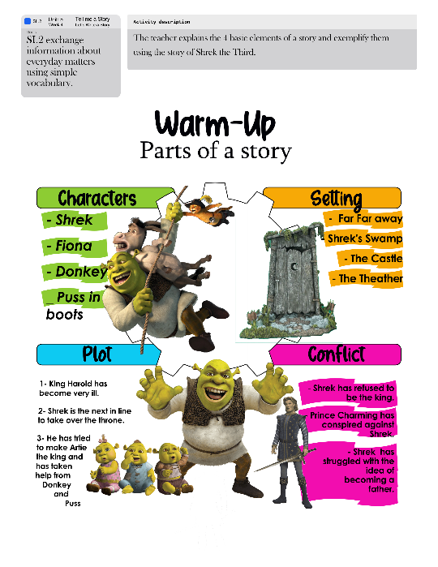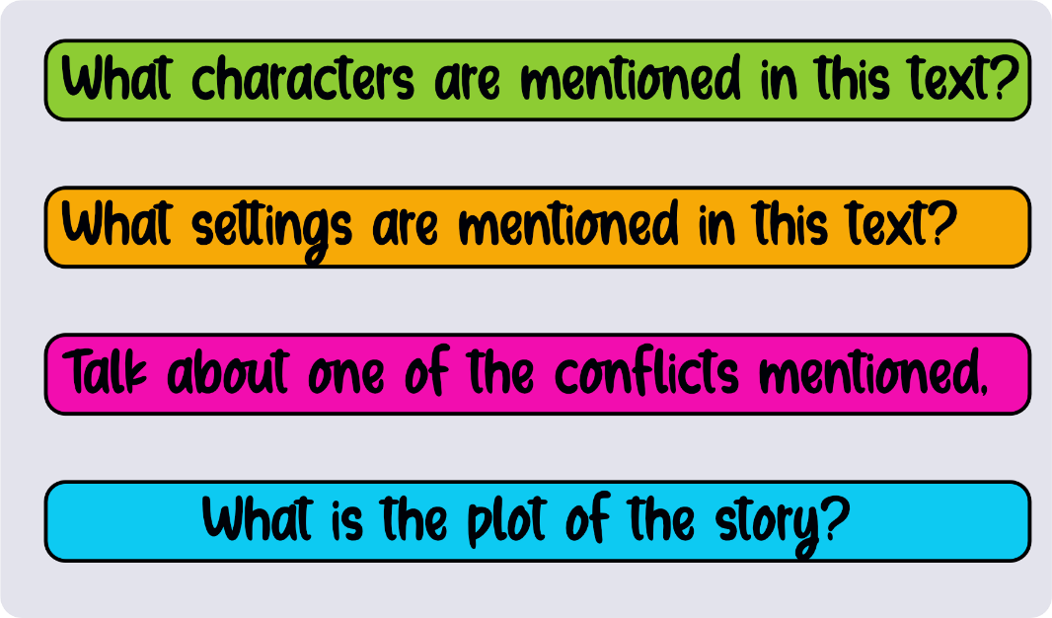

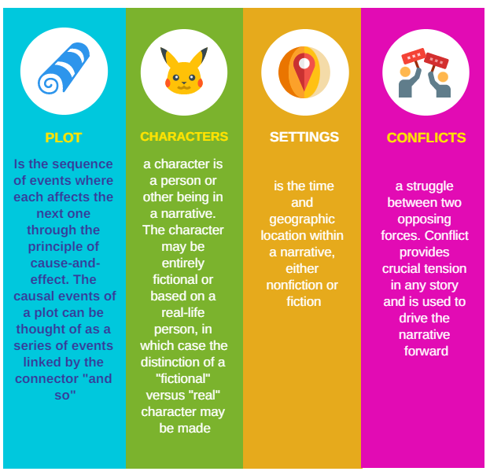

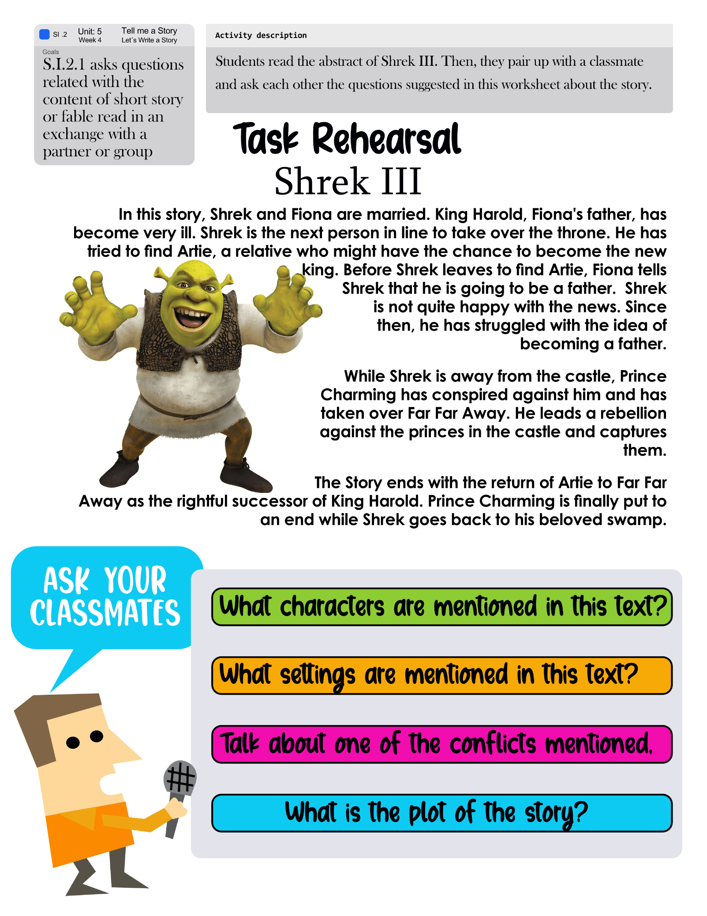

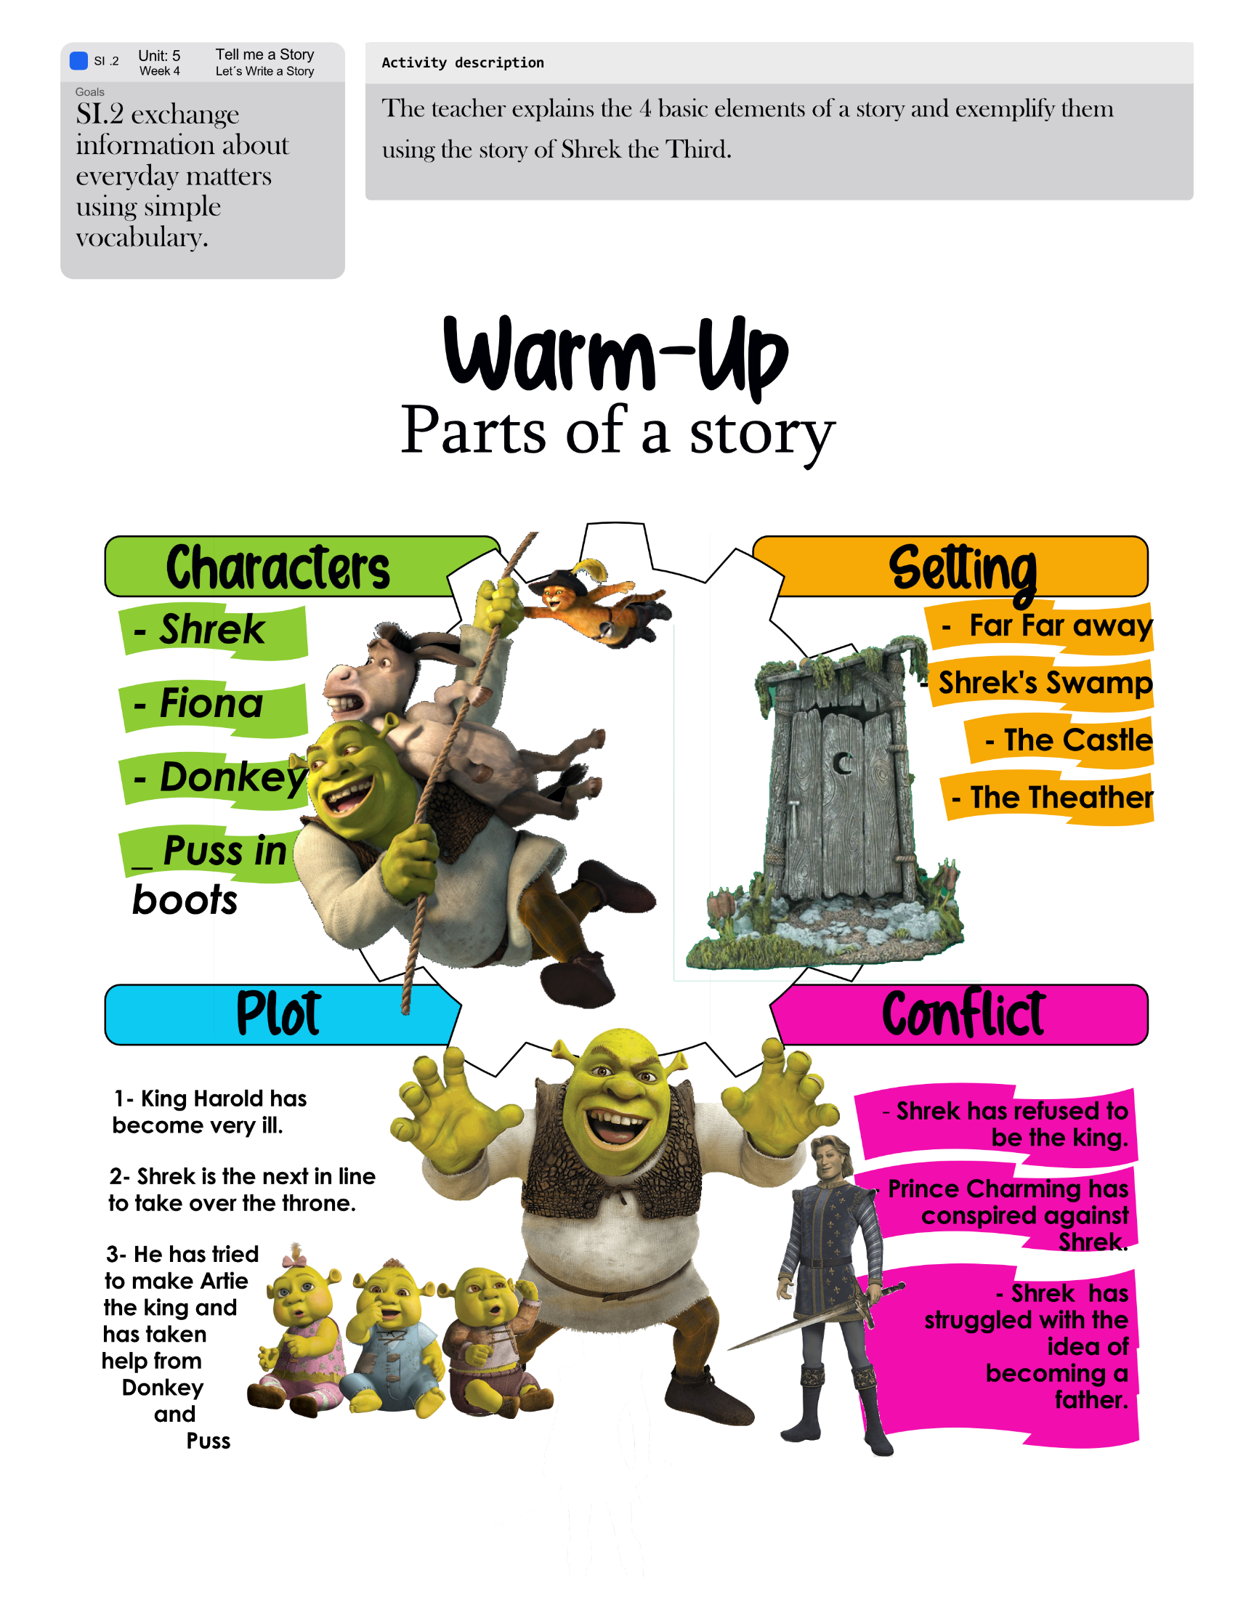

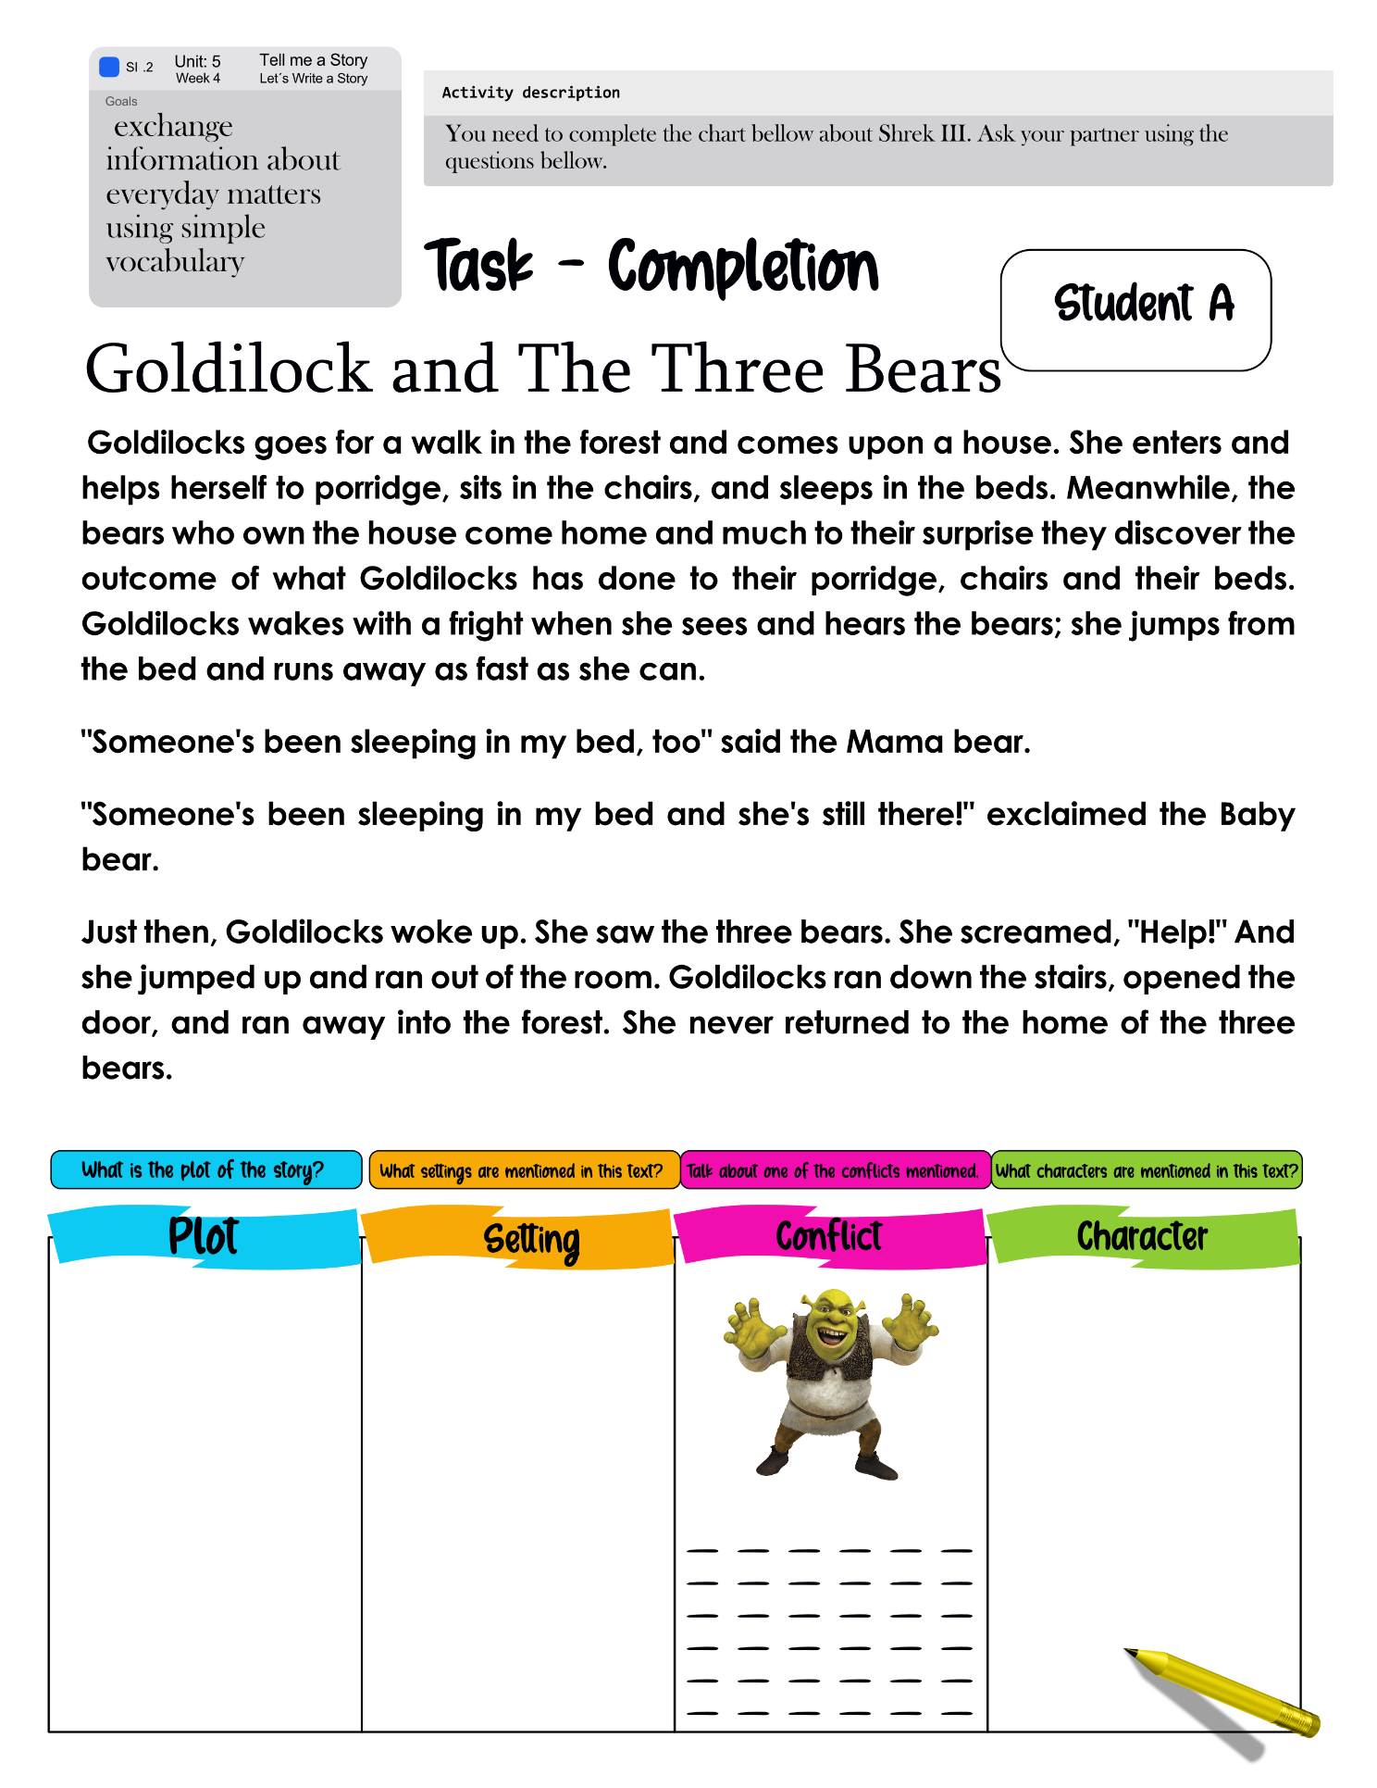

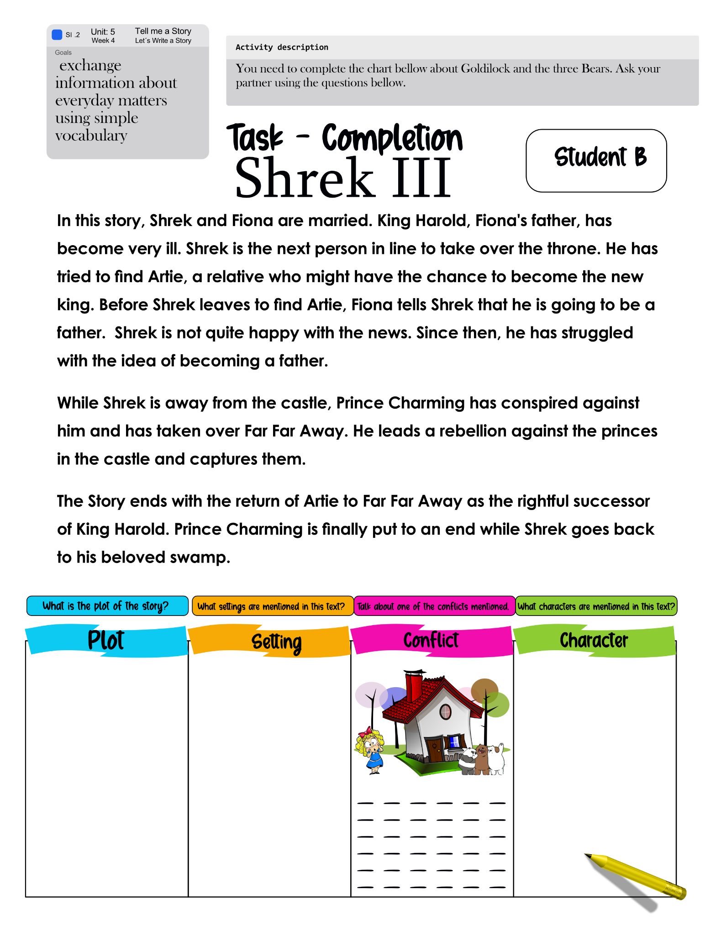

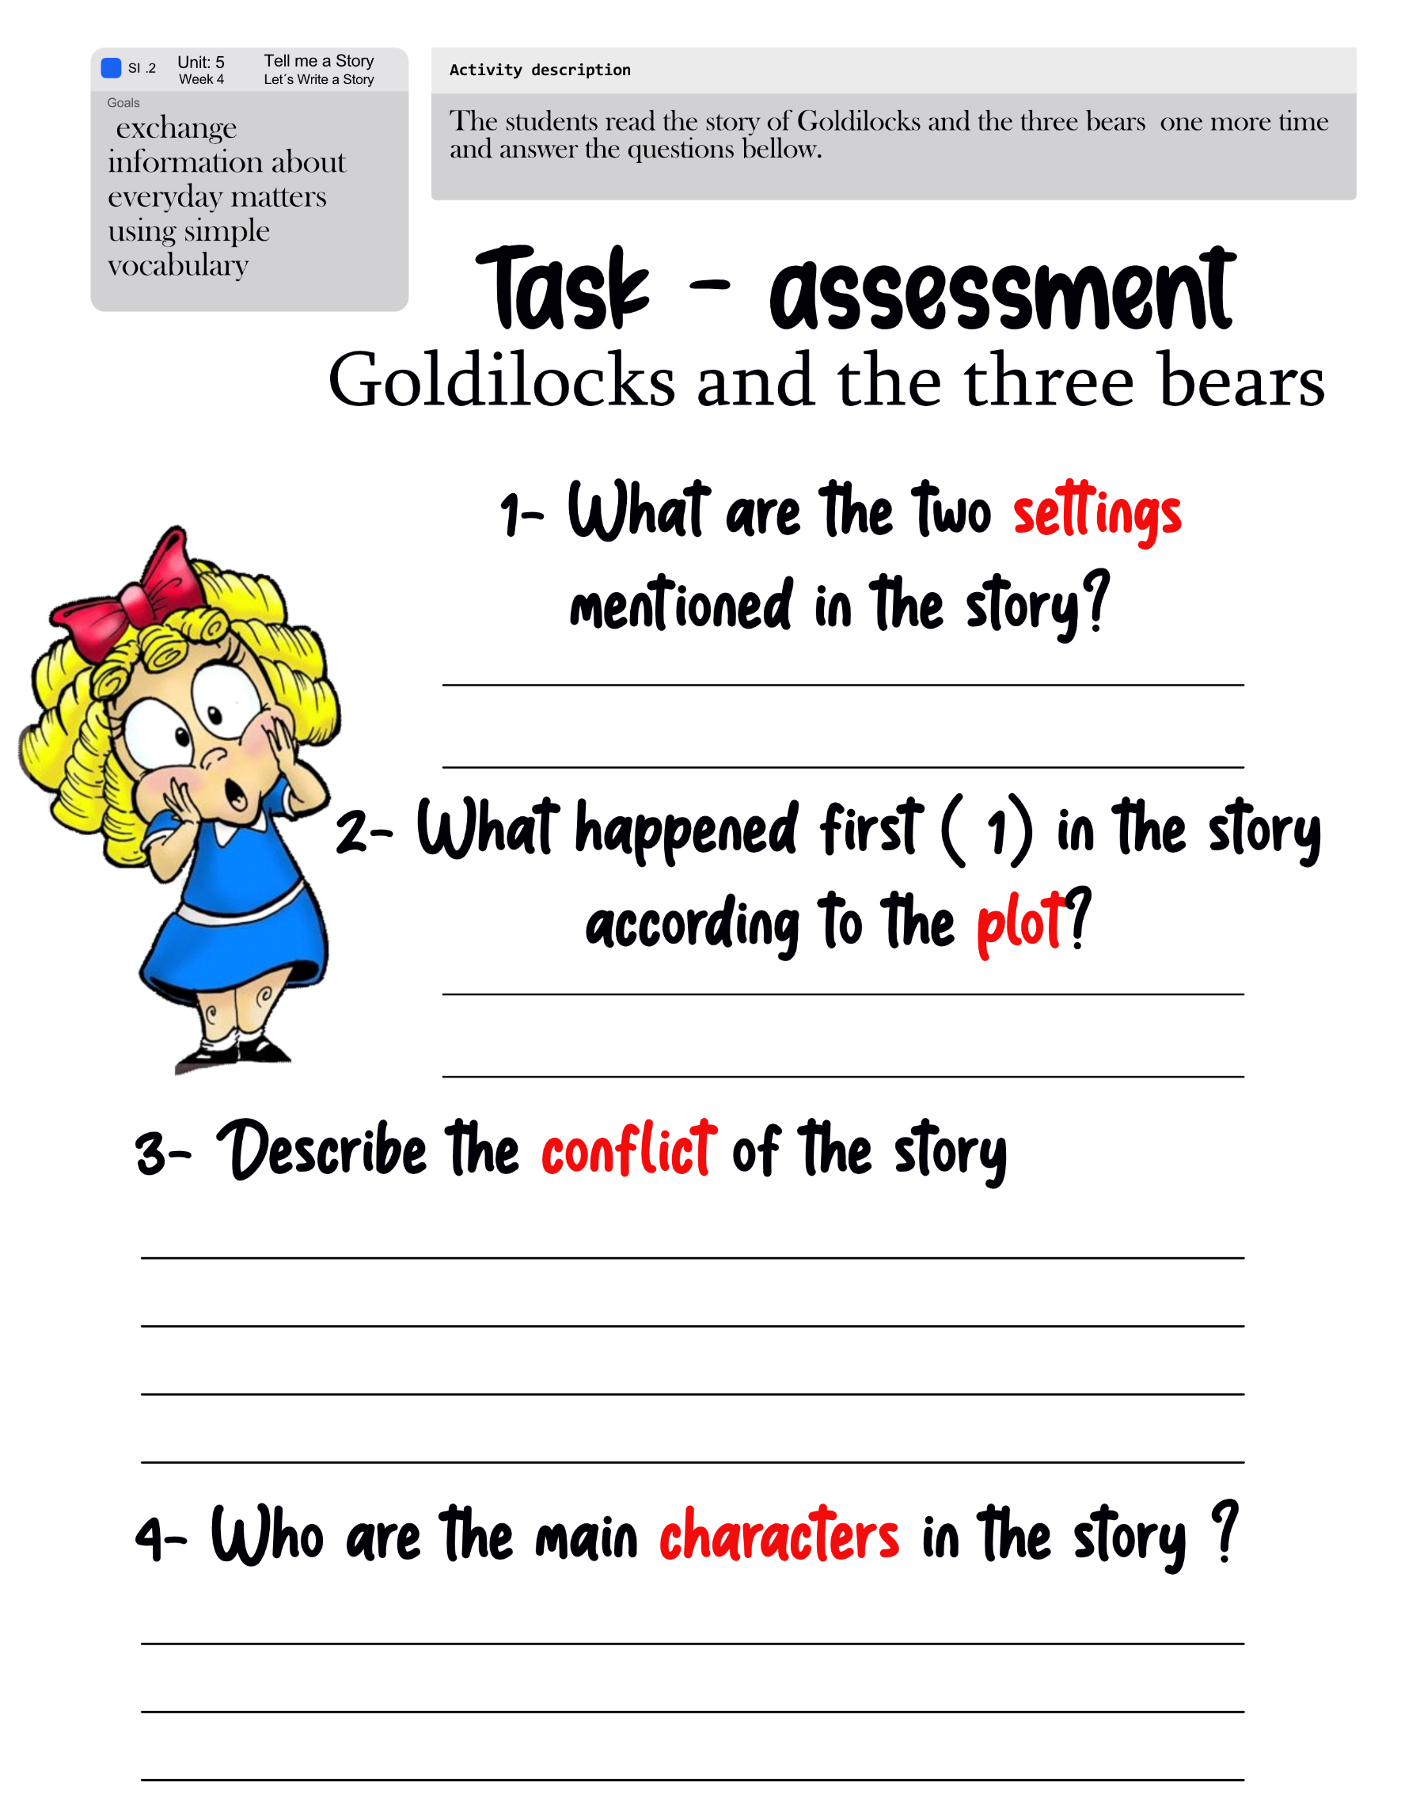

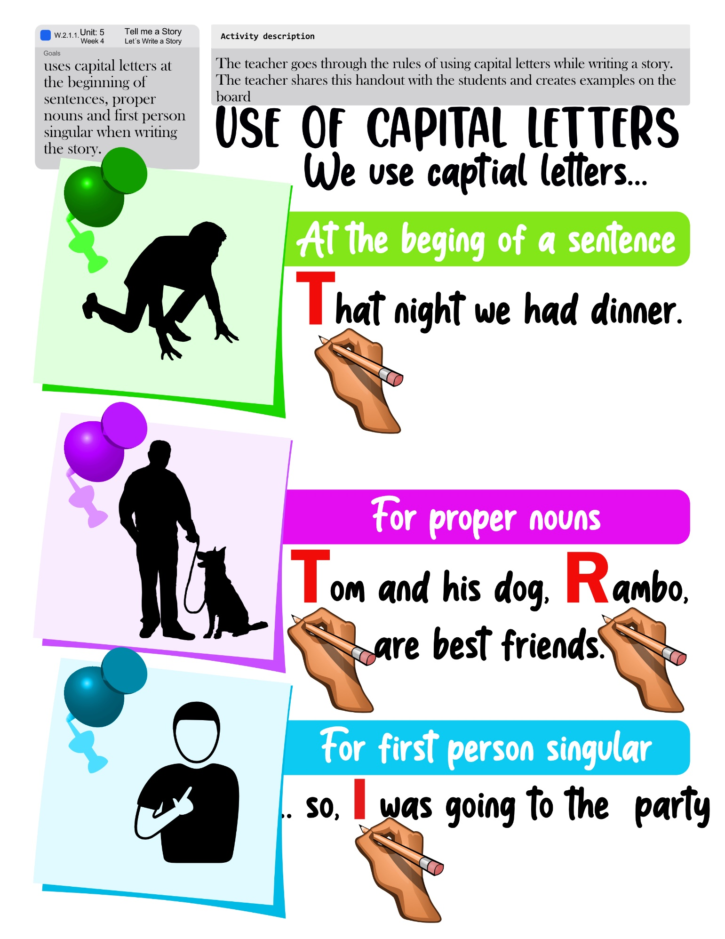

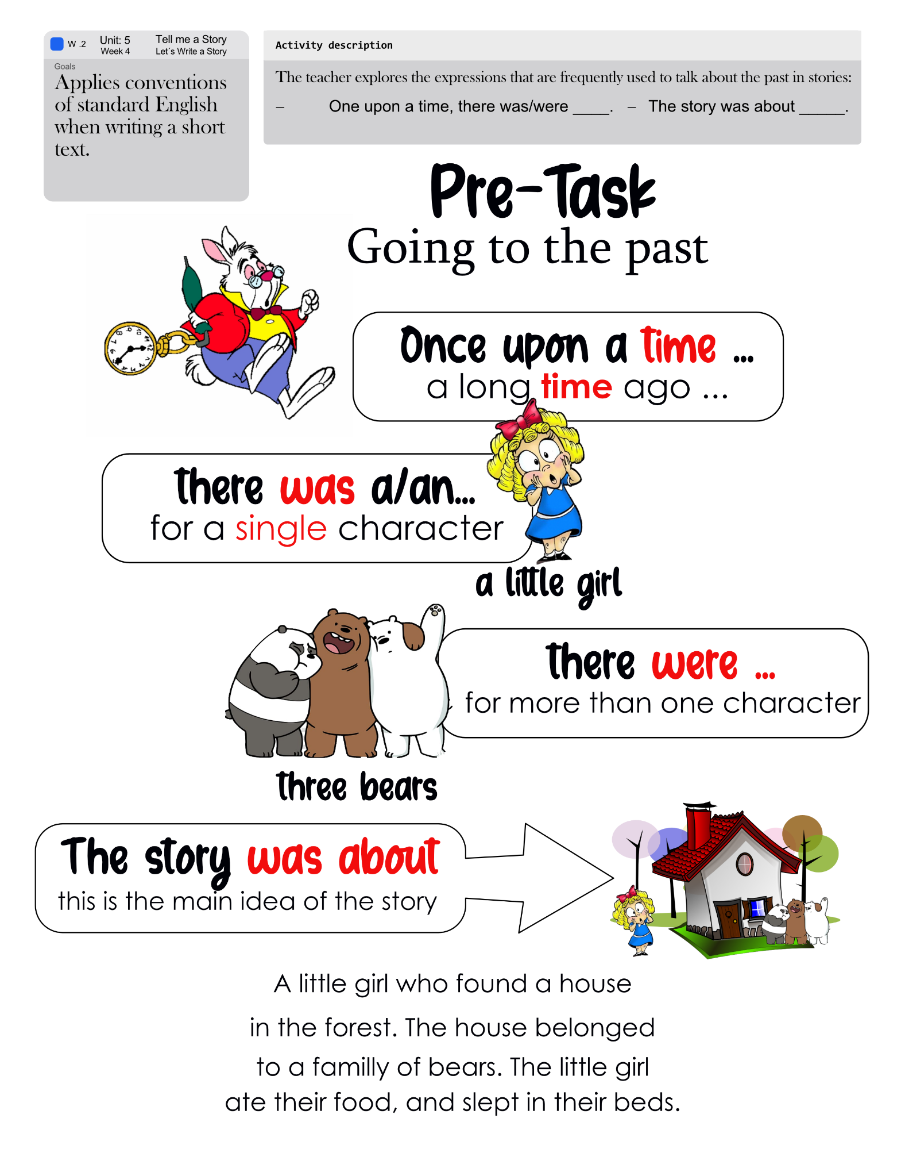

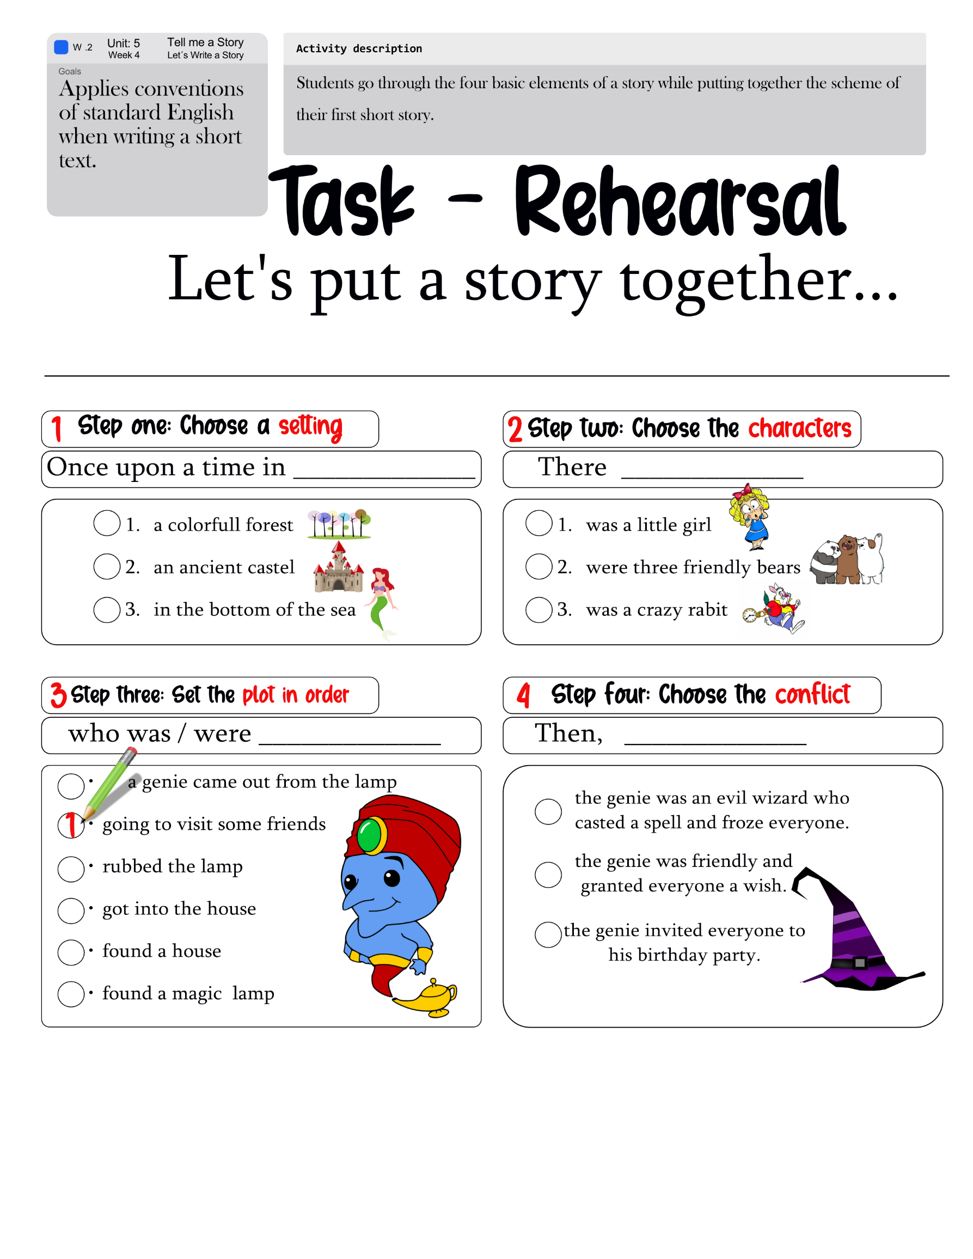

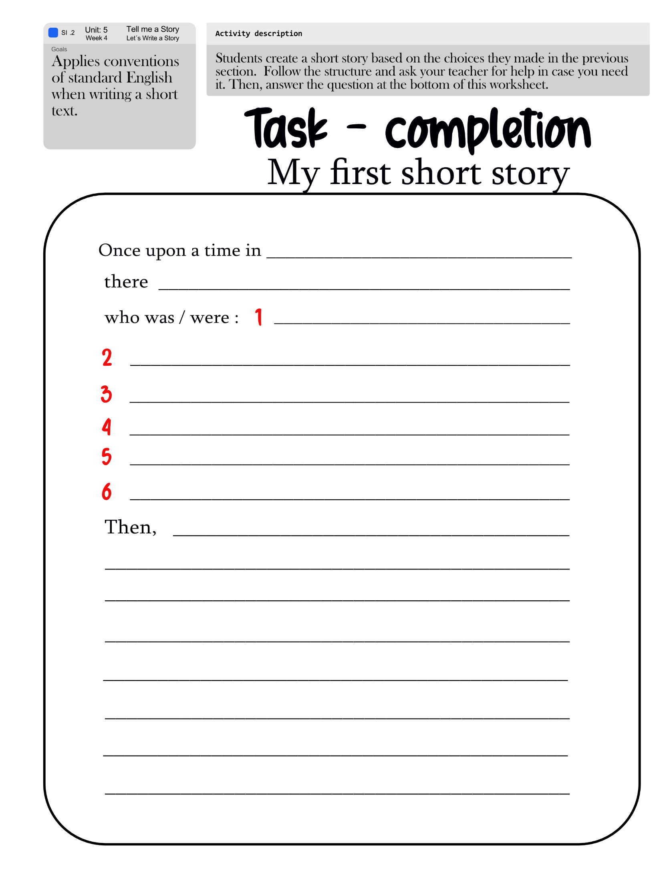

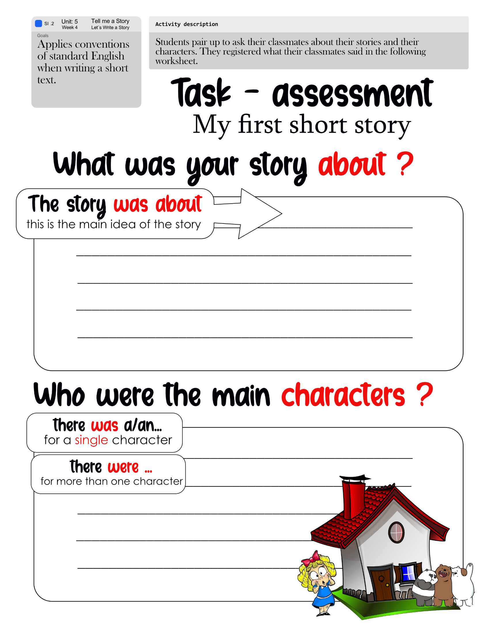

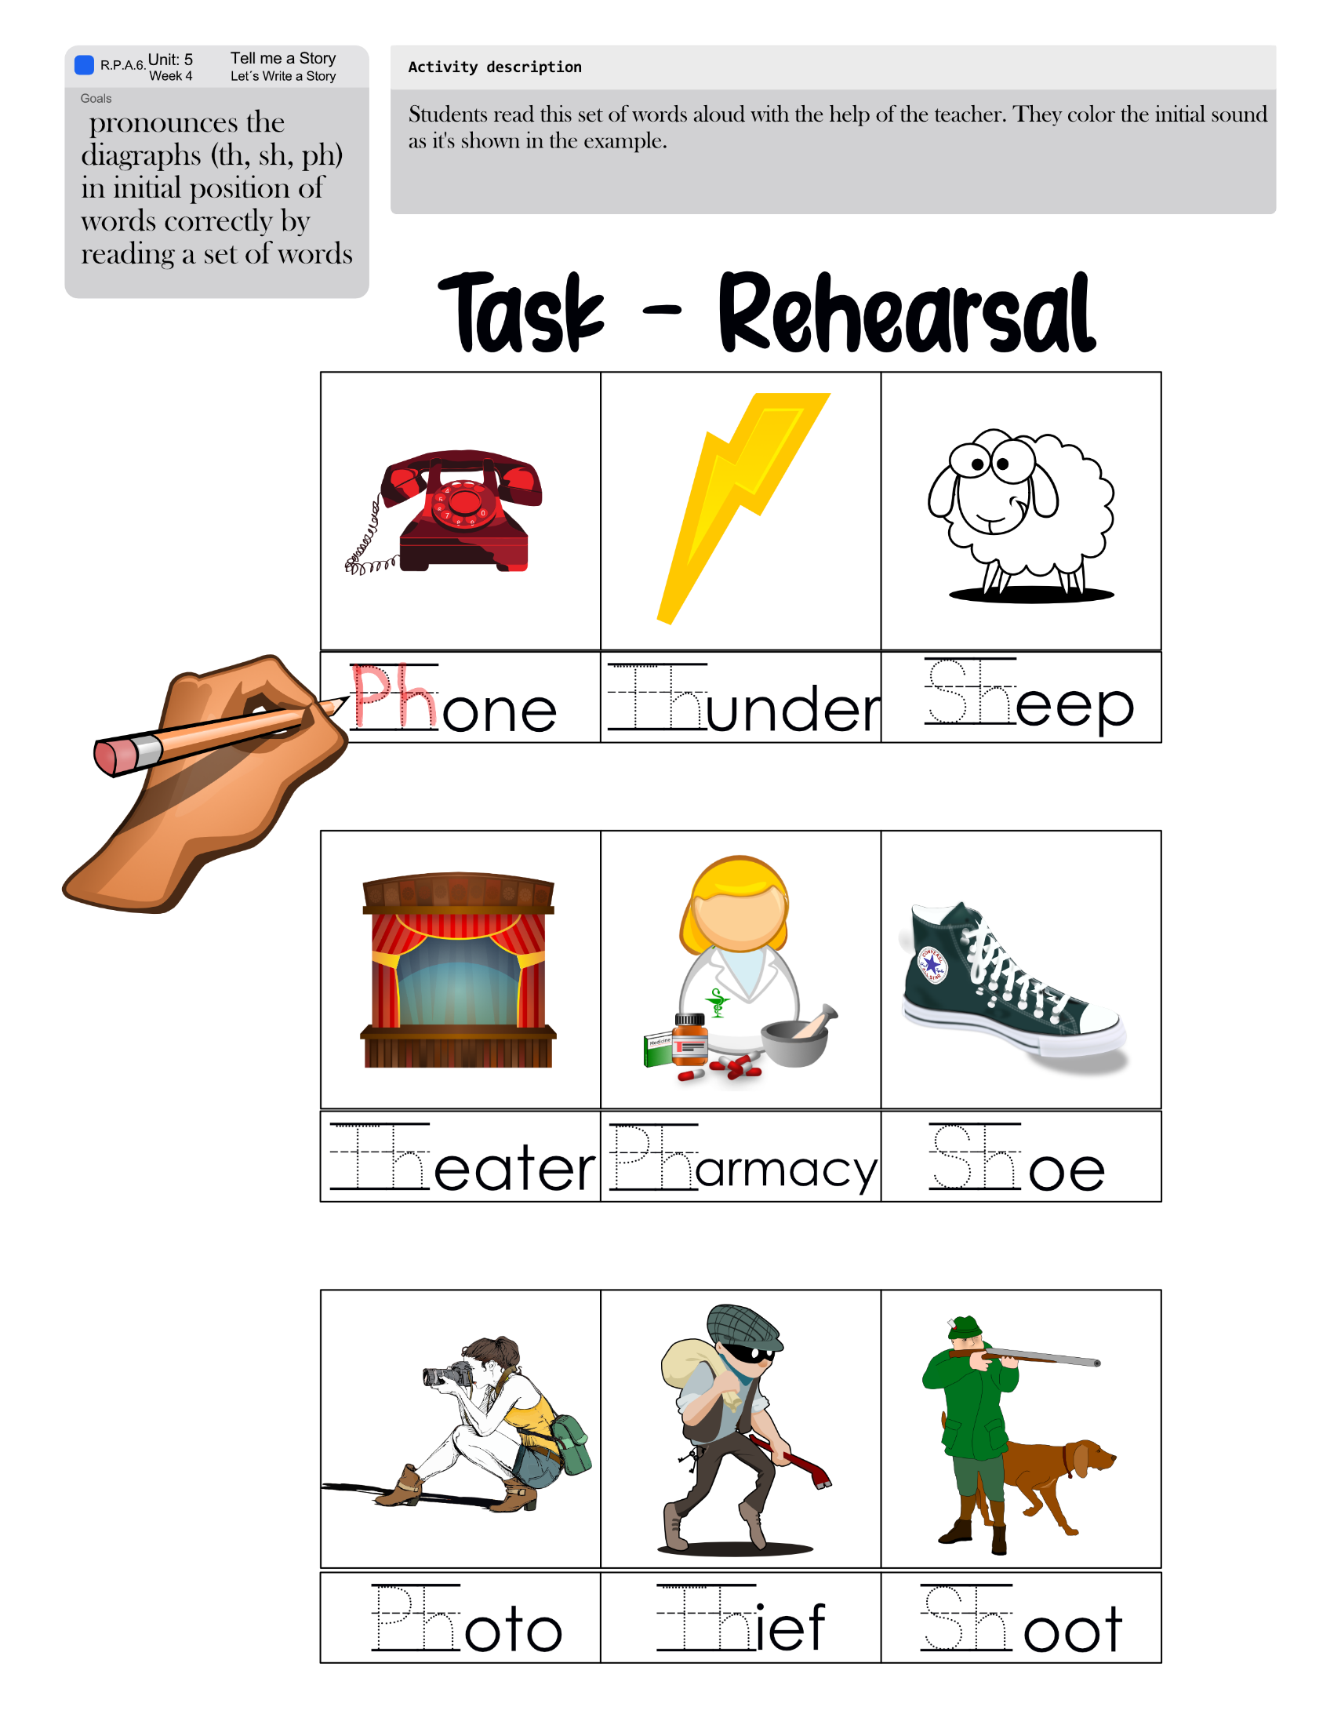

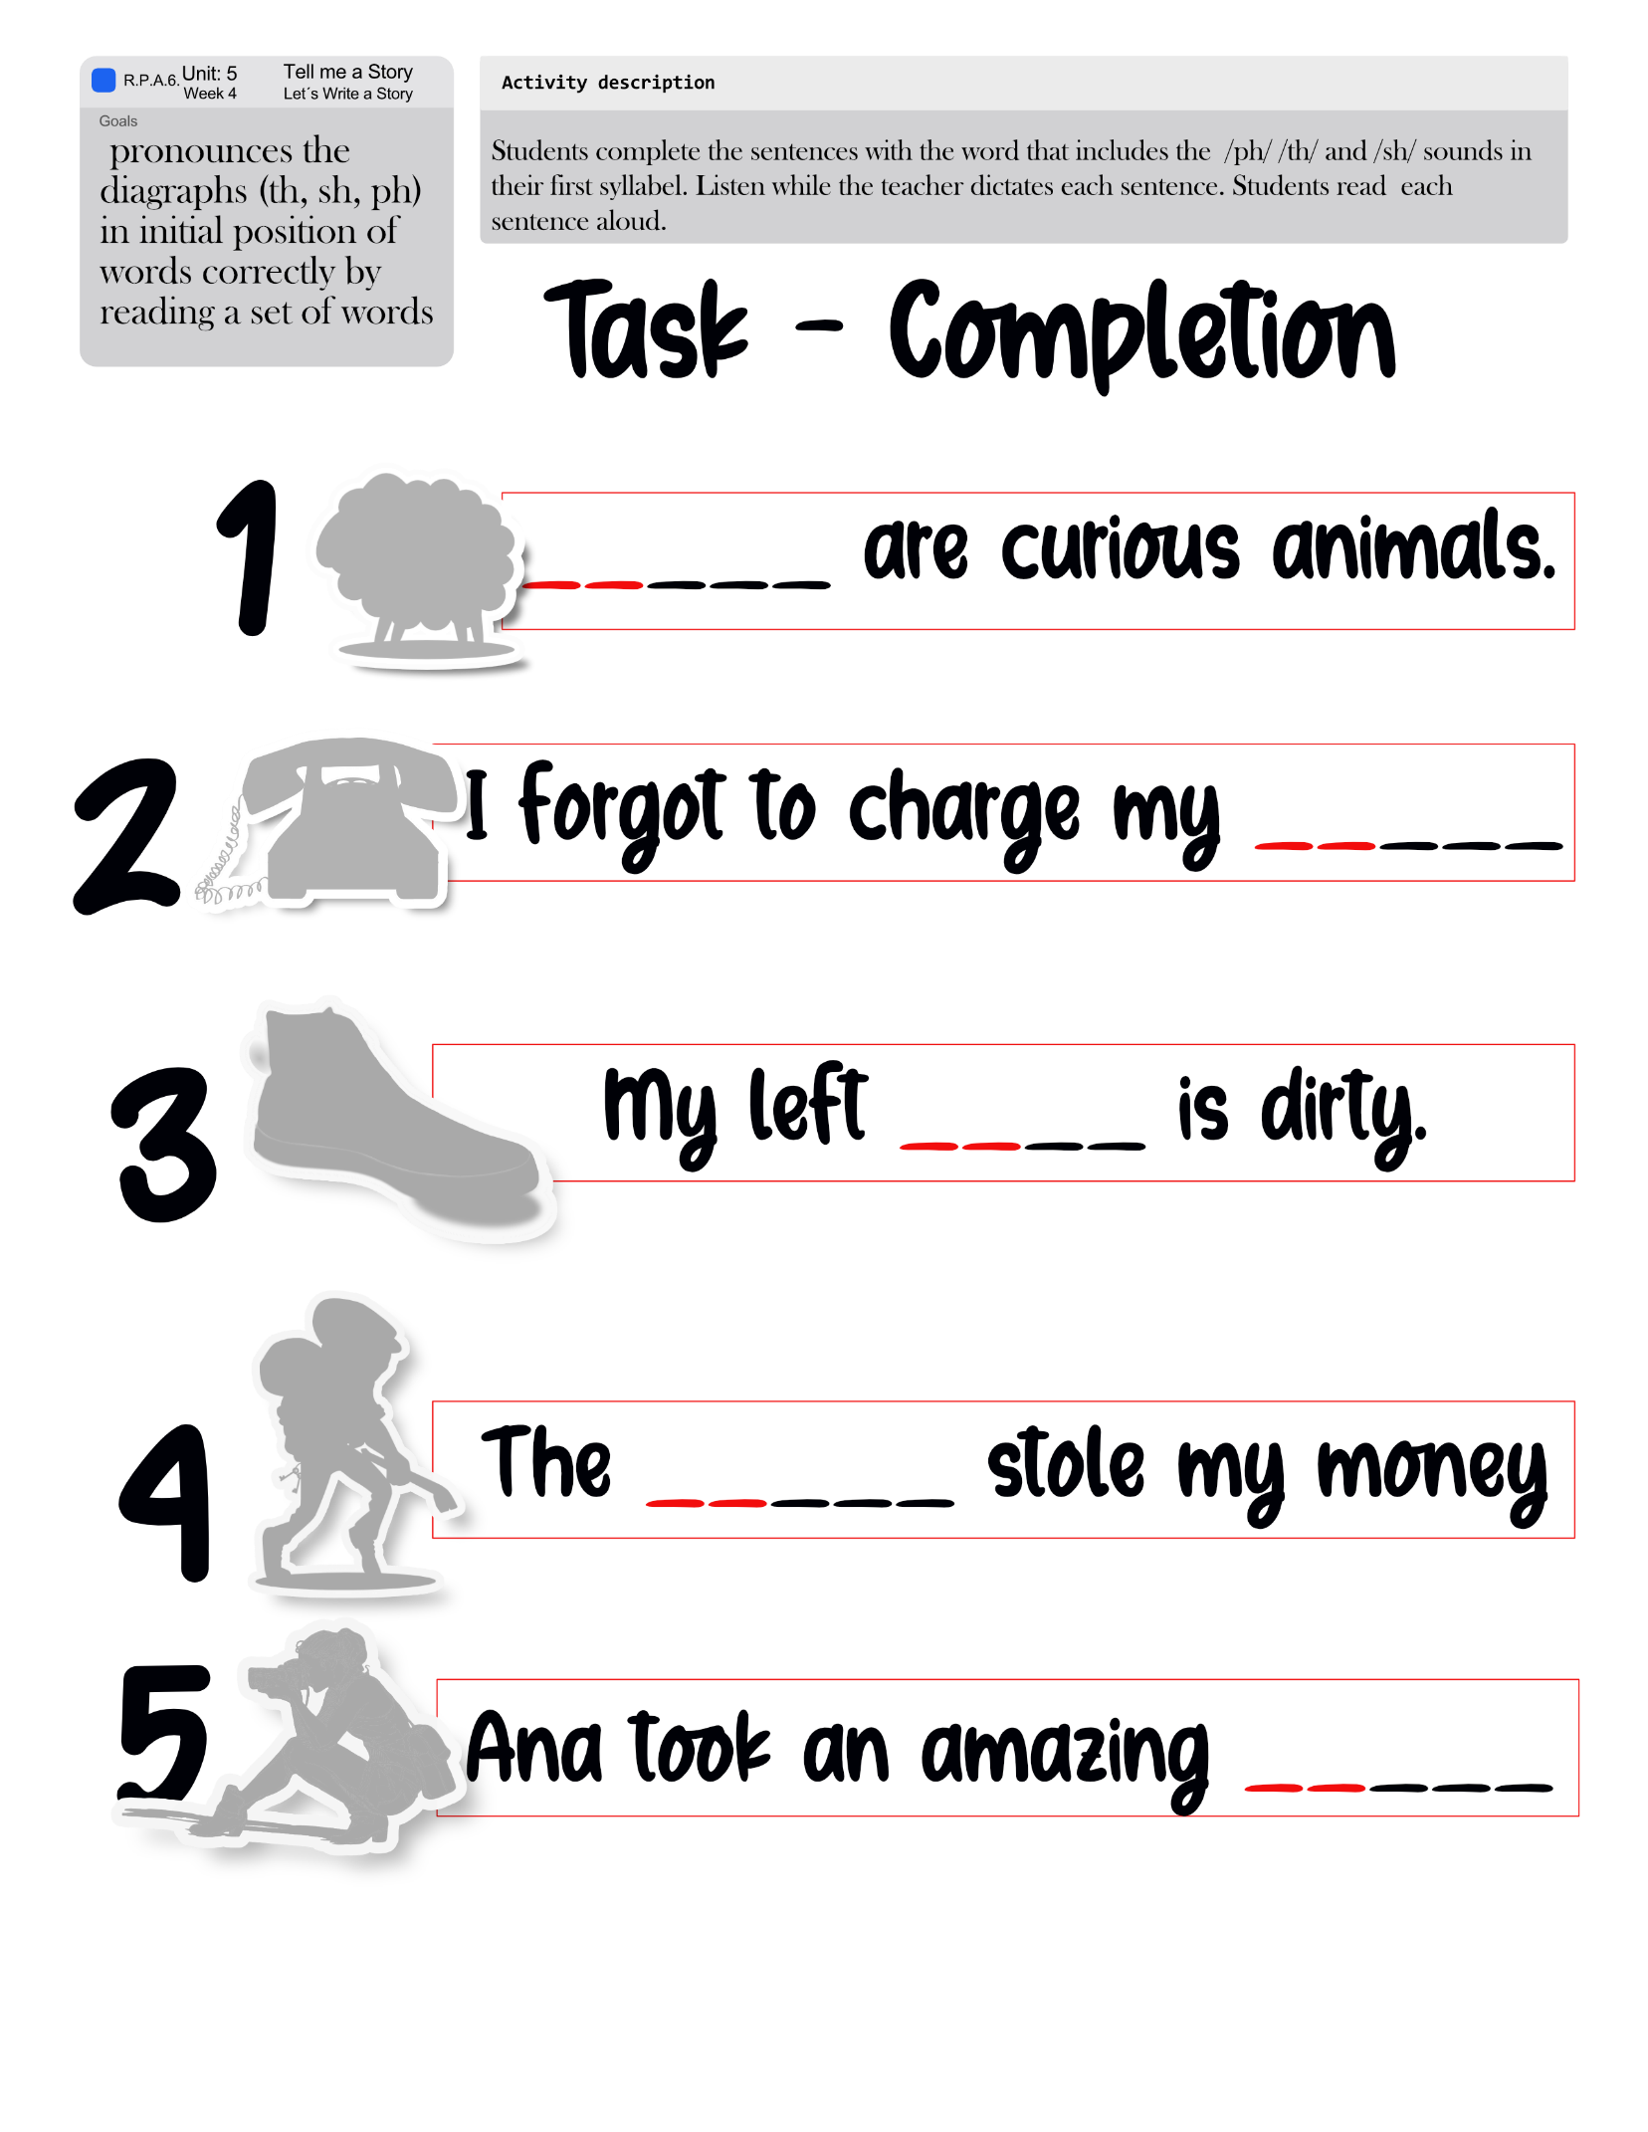

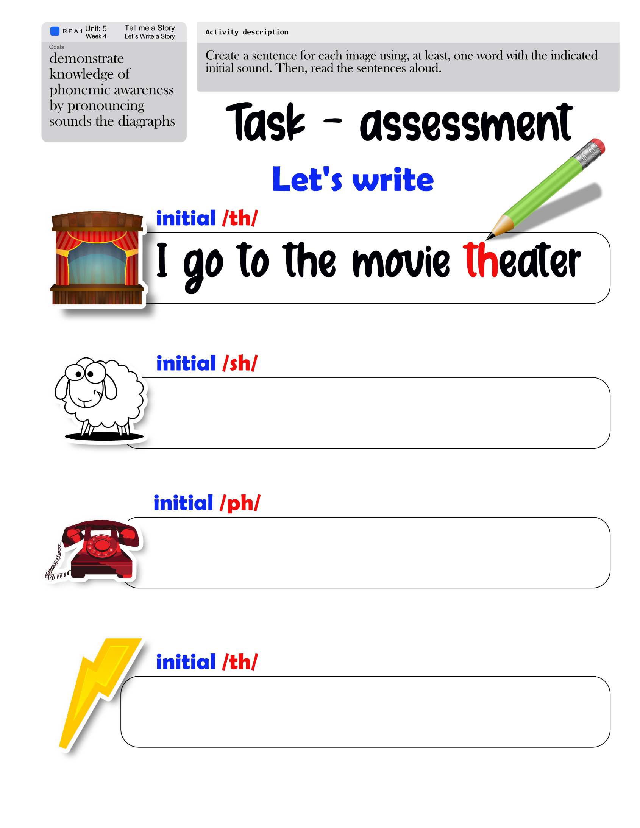

**WEEK 1**

<https://www.youtube.com/watch?v=lMno9beR64g>

<https://dictionary.cambridge.org/dictionary/english/fable>

<https://dictionary.cambridge.org/dictionary/english/short-story?q=short+stories>

<https://dictionary.cambridge.org/dictionary/english/fairy-tale>

<https://dictionary.cambridge.org/dictionary/english/comic>

<https://dictionary.cambridge.org/dictionary/english/poetry?q=Poetry>

<https://dictionary.cambridge.org/dictionary/english/legend>

<https://learnenglishkids.britishcouncil.org/short-stories/robin-hood>

<https://www.youtube.com/watch?v=749w-InEXgQ>

<https://www.youtube.com/watch?v=8ZvPS7bElnI>

<https://www.youtube.com/watch?v=1orYZAoGgoQ>

<https://www.youtube.com/watch?v=wLu-bccANRg>

**WEEK 2**

# <https://www.youtube.com/watch?v=GbzMC6qAzVU>

# <https://www.youtube.com/watch?v=TR5RcutMu7c>

<https://www.youtube.com/watch?v=RMSCgmXHWok>

<https://www.youtube.com/watch?v=JwGnCIsLOpU>

**WEEK 3**

[**https://www.youtube.com/watch?v=dT9ZeKwbVhk**](https://www.youtube.com/watch?v=dT9ZeKwbVhk)

<https://www.youtube.com/watch?v=Ih55yasmR-Q>

<https://www.youtube.com/watch?v=ptfu3tL0OBg>

[http://bit.ly/ph-sound](http://bit.ly/ph-sound%20).

**WEEK 4**

<https://www.youtube.com/watch?v=ptfu3tL0OBg>

[http://bit.ly/ph-sound](http://bit.ly/ph-sound%20).

[**http://bit.ly/the-main-idea**](http://bit.ly/the-main-idea)

<https://www.youtube.com/watch?v=Ih55yasmR-Q>

<https://www.youtube.com/watch?v=ptfu3tL0OBg>

[http://bit.ly/ph-sound](http://bit.ly/ph-sound%20)

### CREDITS

*Pictures:*

*Depositphotos*

Videos:

*Youtube.com*

learnenglishkids.britishcouncil.org/

Worksheets:

learnenglishkids.britishcouncil.org/

*MES English*

Elaboration and Materials’ Design

*Licda. Livia Gamboa Cordero*

*English Regional Advisor – DRE San Carlos*

*Lic Royner Vinicio Villalobos*

*English Teacher San Francisco de Florencia School and Caimitos de Florencia School*

*Revision and final edition*

*Lic.Randall Centeno Hernandez, national English Advisor, Department of First and Second Cycles*

*Dra. Ana Isabel Campos Centeno,national English Advisor, Department of First and Second Cycles*

*Licda. Livia Gamboa Cordero*

*English Regional Advisor – DRE San Carlos*

*Lic Royner Vinicio Villalobos*

*English Teacher San Francisco de Florencia School and Caimitos de Florencia School*